Q1) **Create a virtual network with 2 subnets. Each subnet should have 16 Ips only.**

**Step 1**

Resorce Group

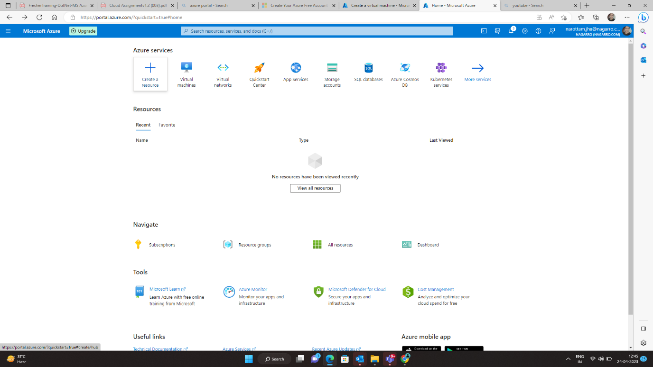

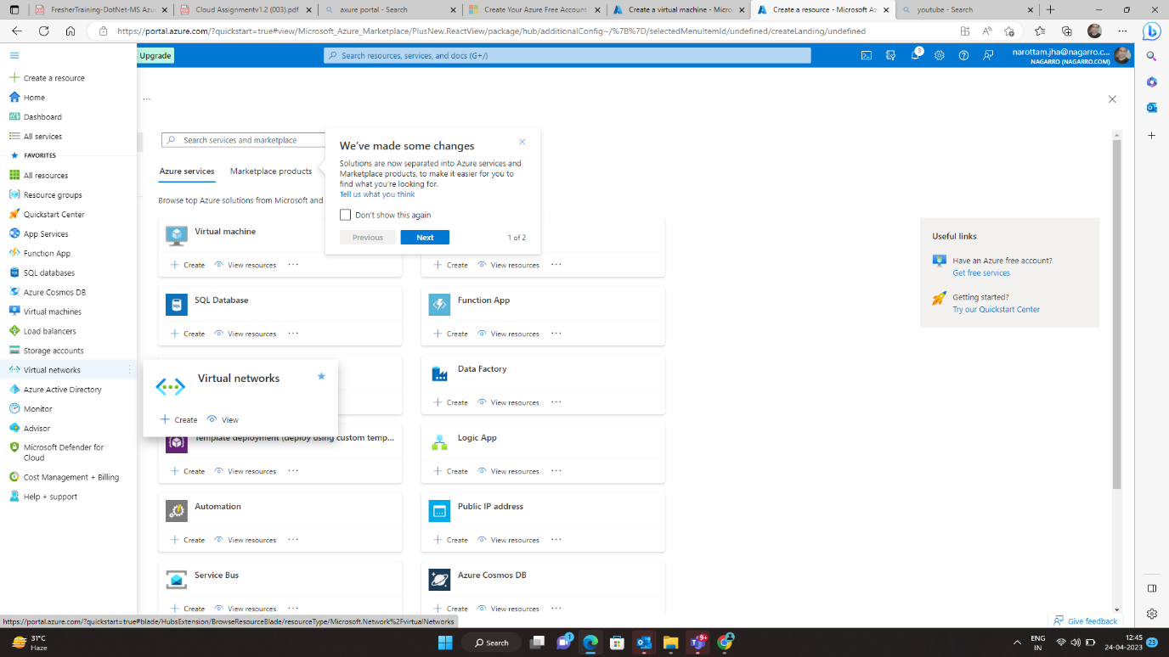

Step 2

Go to menu -> Create Virtual Network

**Filling Data**

Resorce – NewRg01

Region – East US

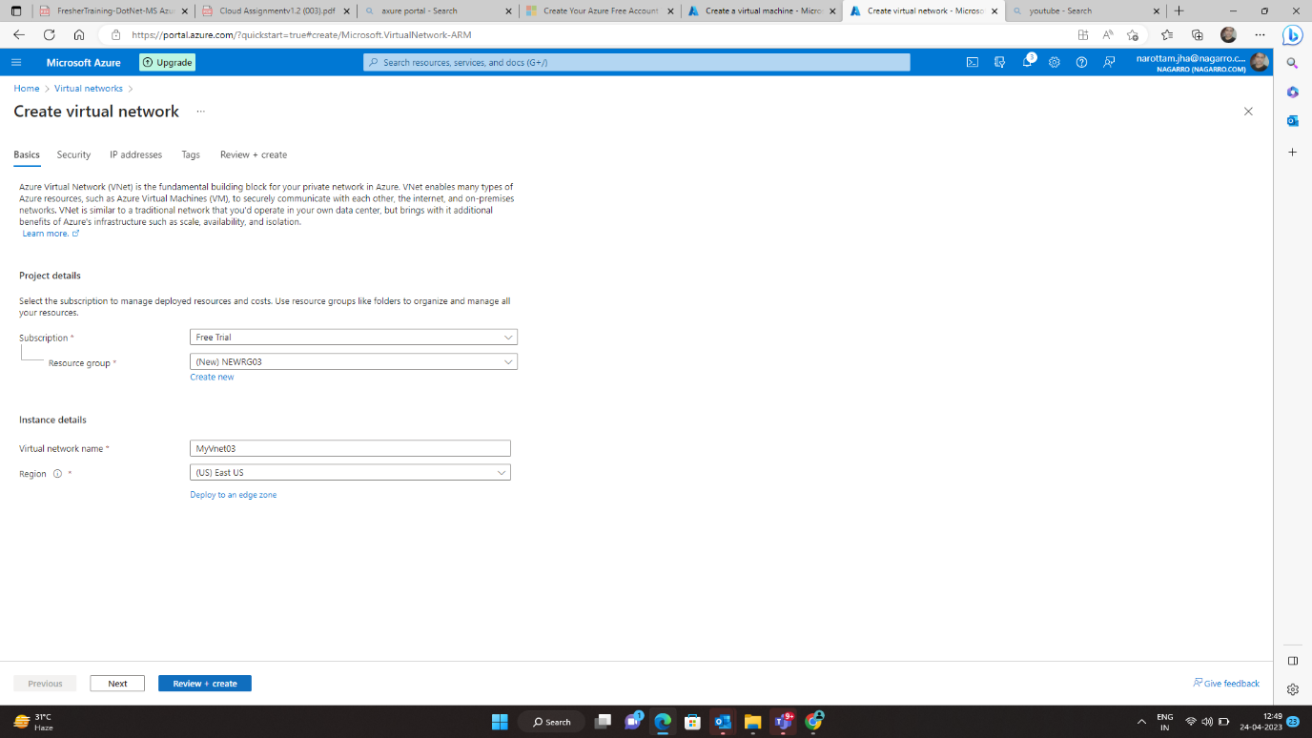

Step 3

**Click** – Review + Create

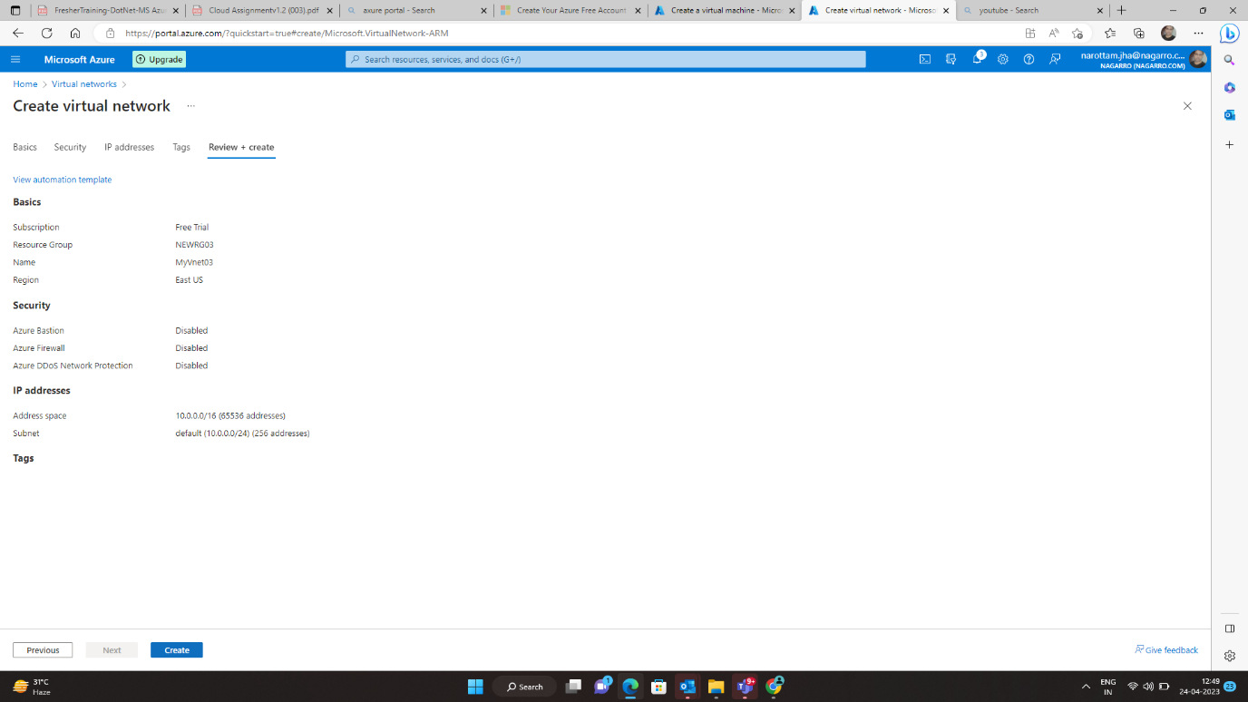

Step 4

Next Step – click on create

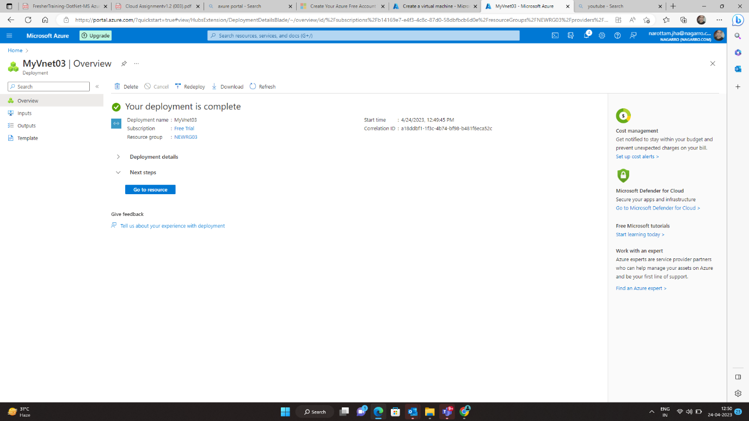

Deployment is ompleted

Step 5

Go to Resource

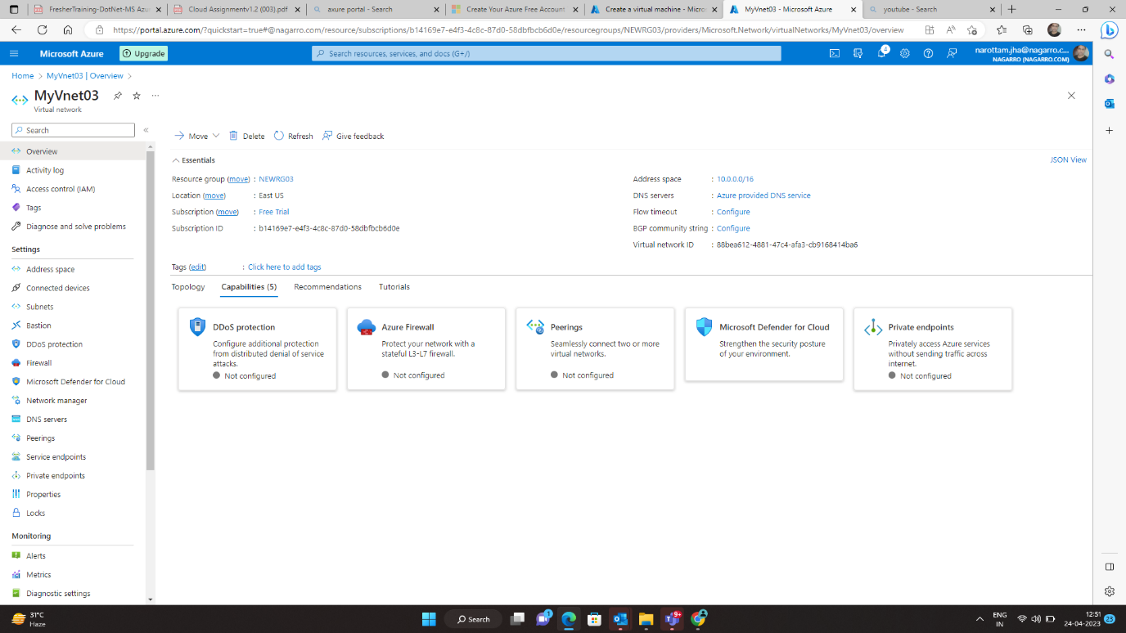

Step 6

Home – Resource group 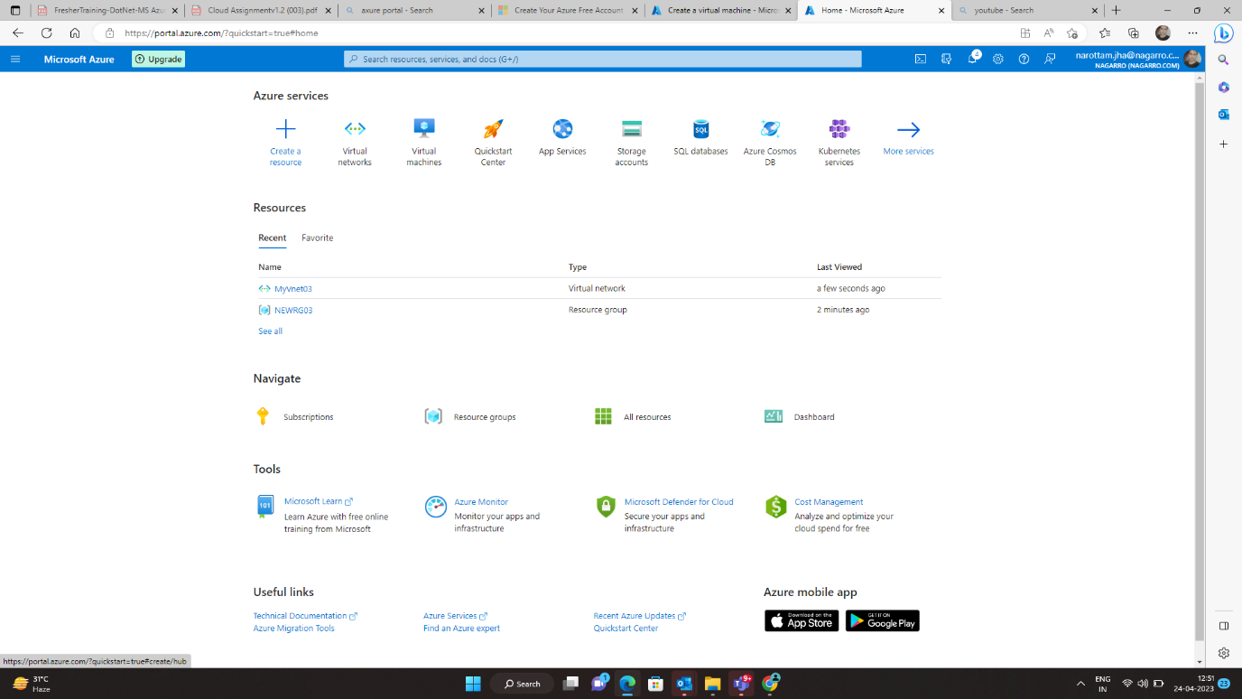

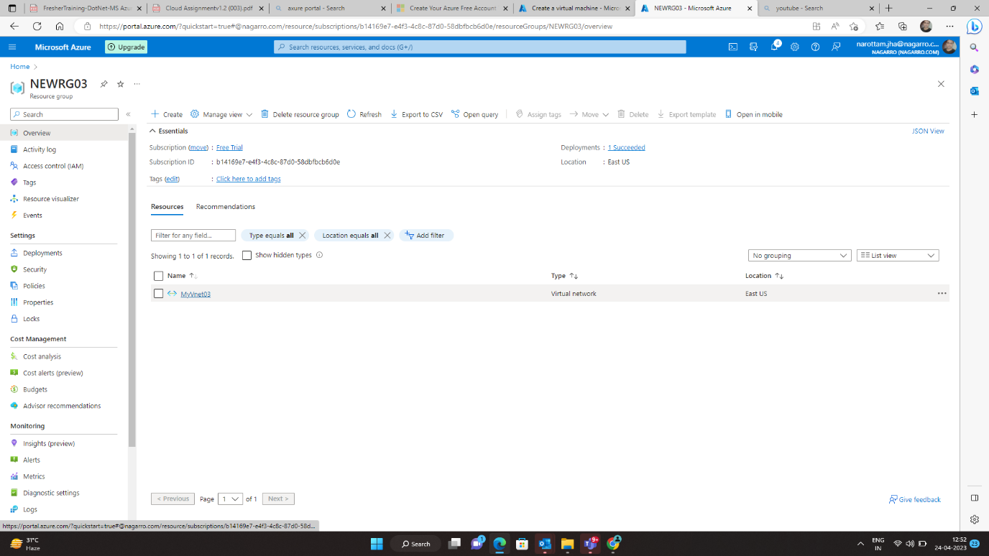

Step 7

Go to myvnet03 – subnet

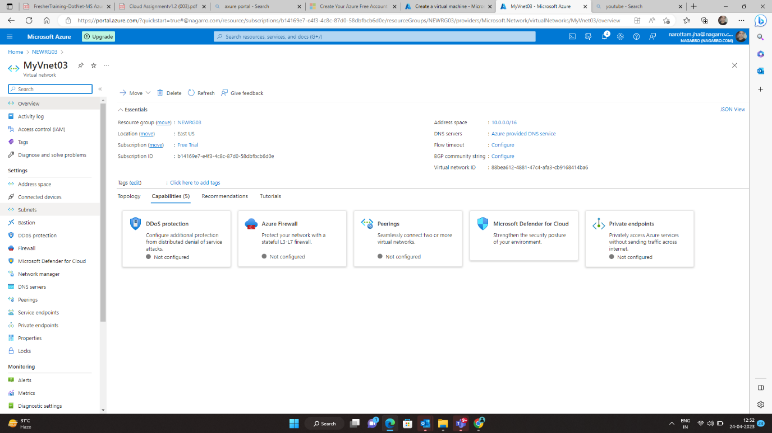

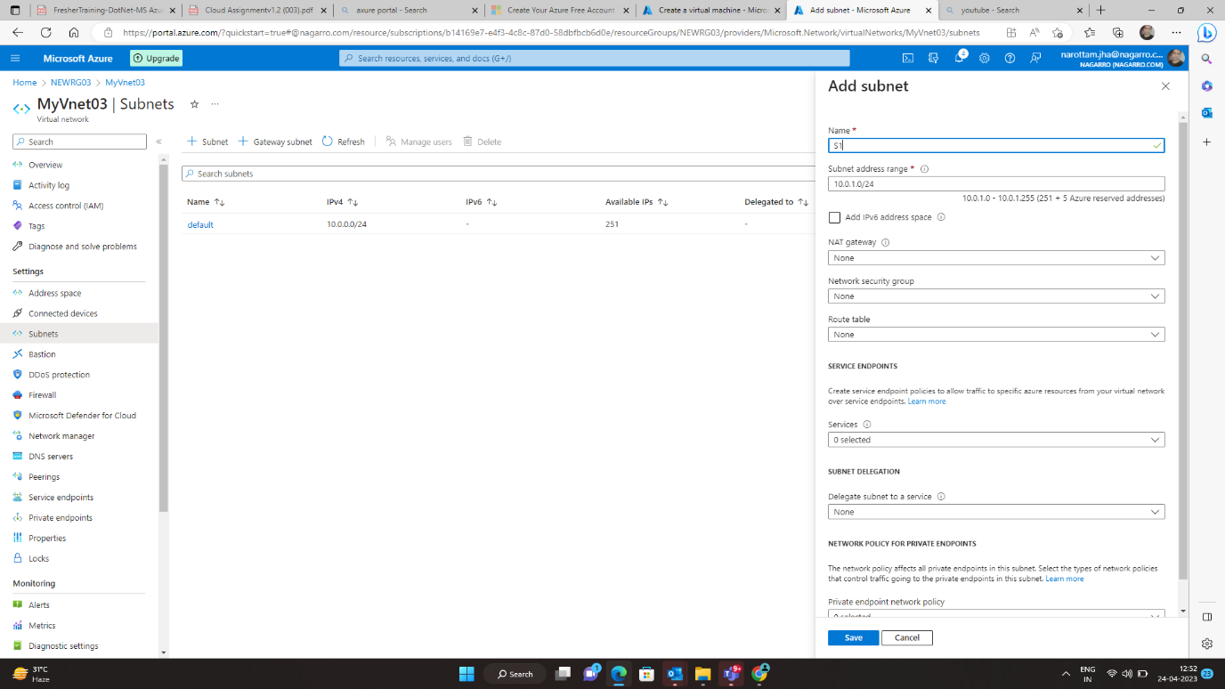

There is a default subnet

Now we will add two subnets

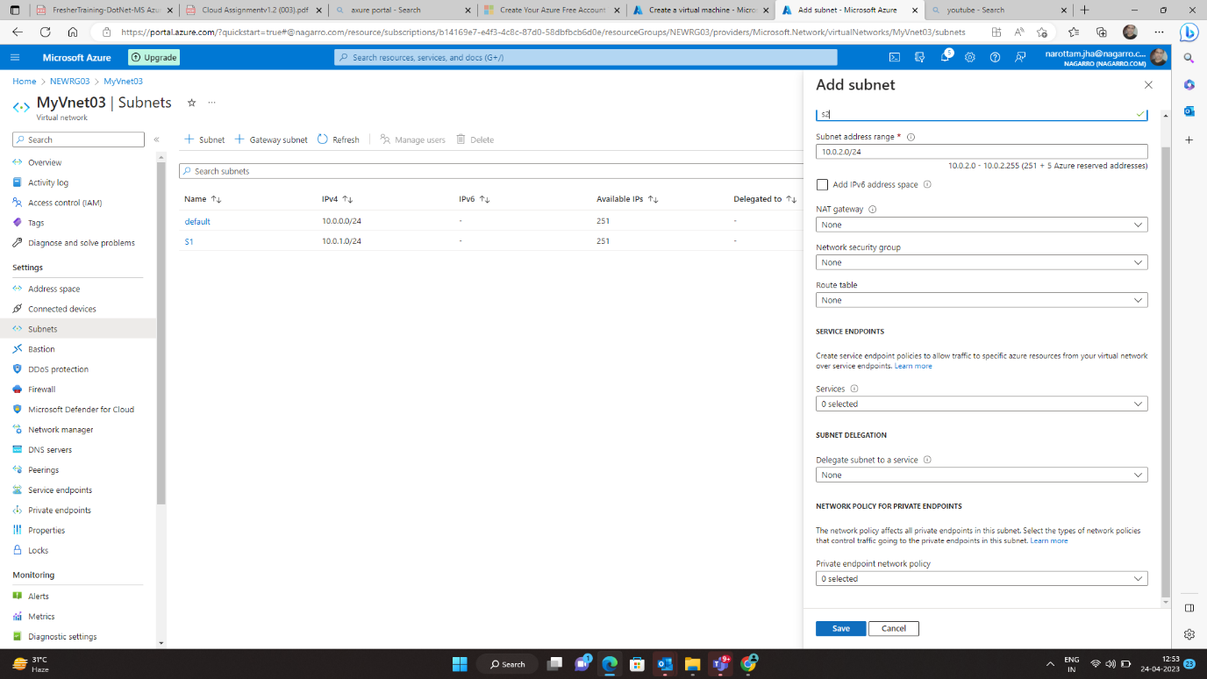

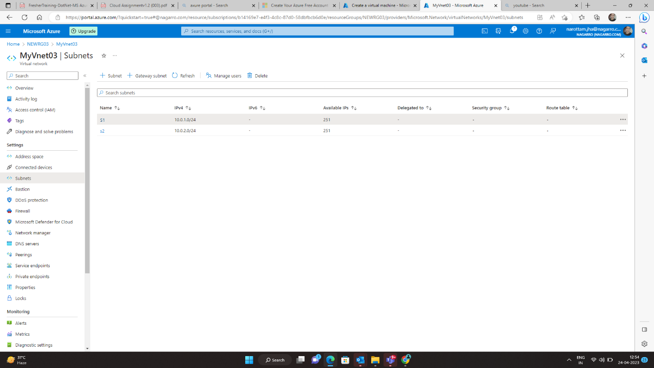

The two subnet s1 and s2 is added

**Q2) Inside one of the subnets, create a VM and deploy an application code inside it and it should leverage the database on the cloud (any existing application created by you before)**

**Step 1**

Creating virtual network

Home – virtual machine

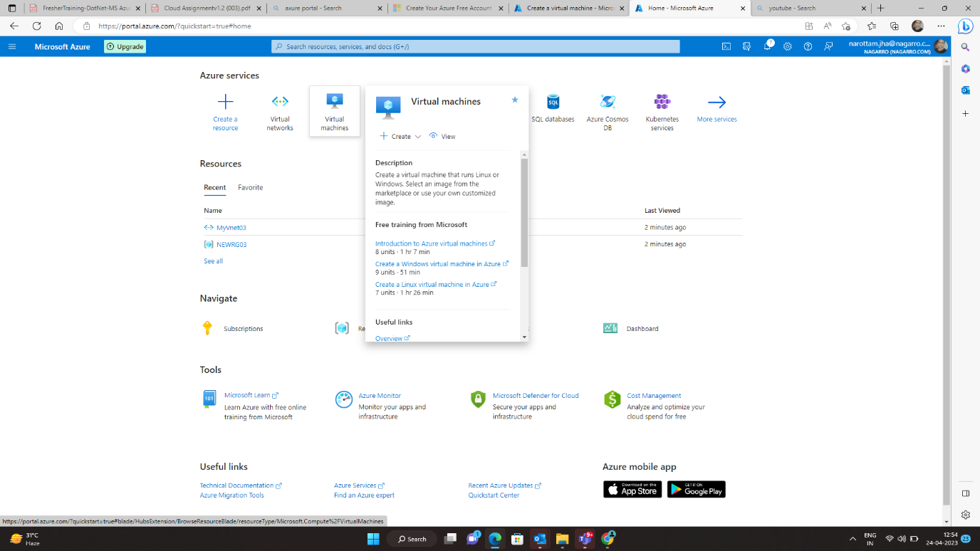

Step 2

Filling the data

User Name and password

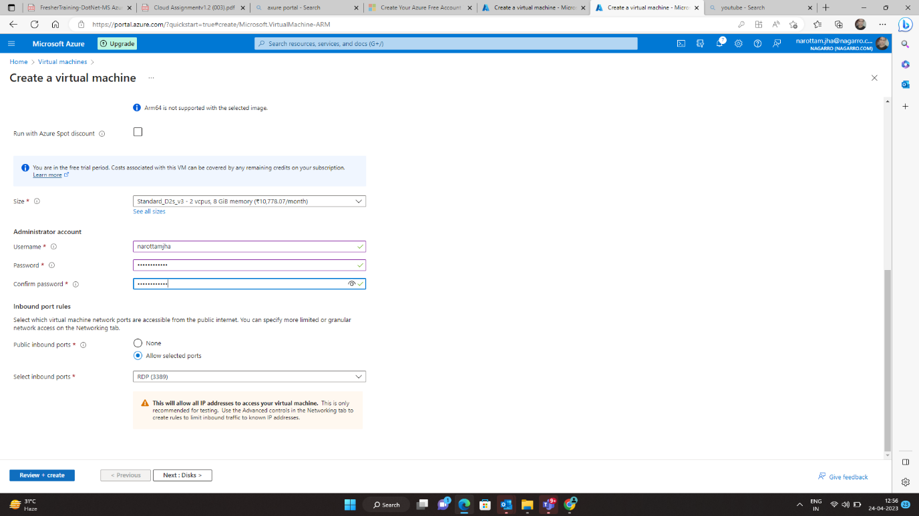

Step 2

Click on – Review + create

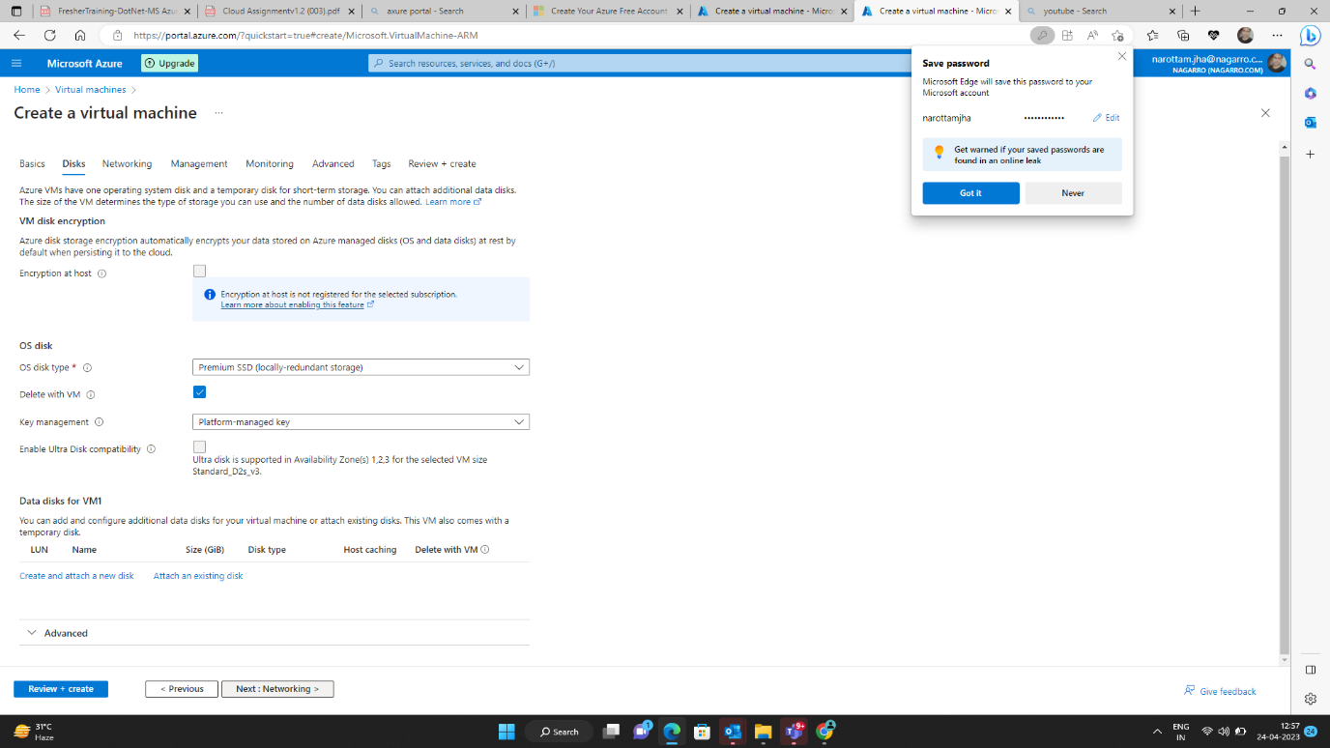

On Disk Page

Step 3

Click on – Review + create

On networking page

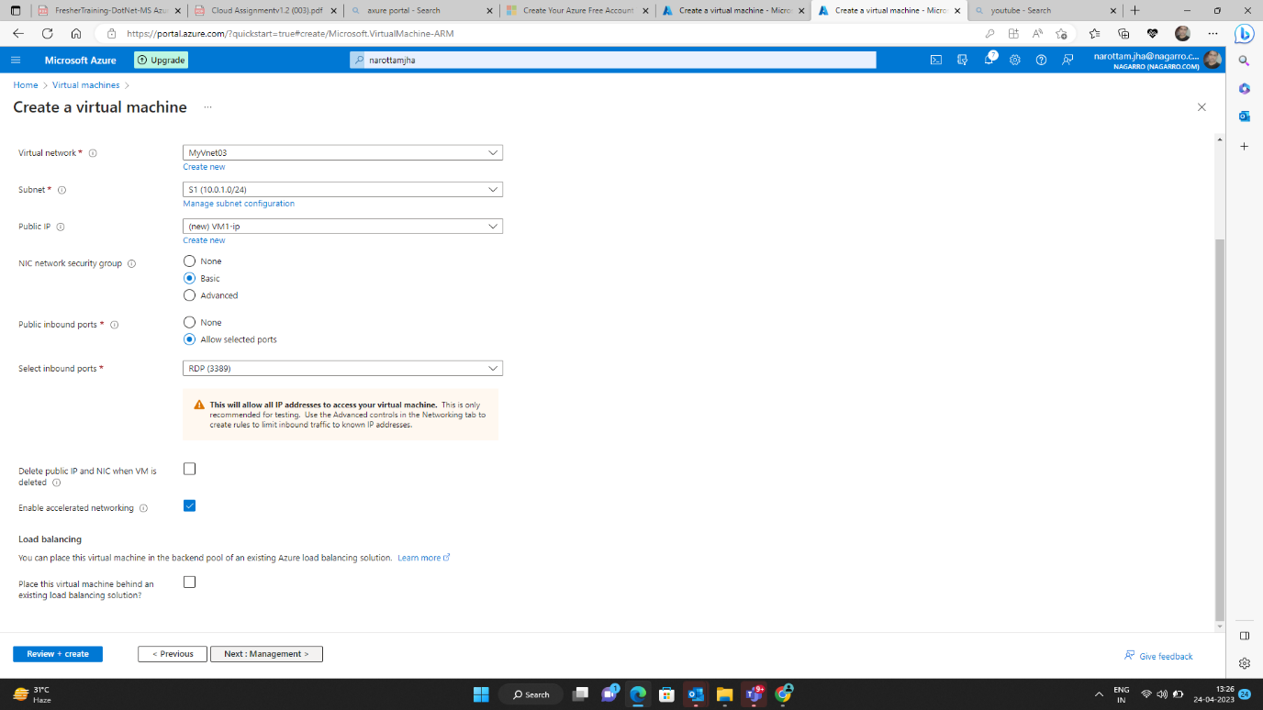

Step 4

Fill the data – virtual network + subnet

Step 5

Click on – Review + create

On management page

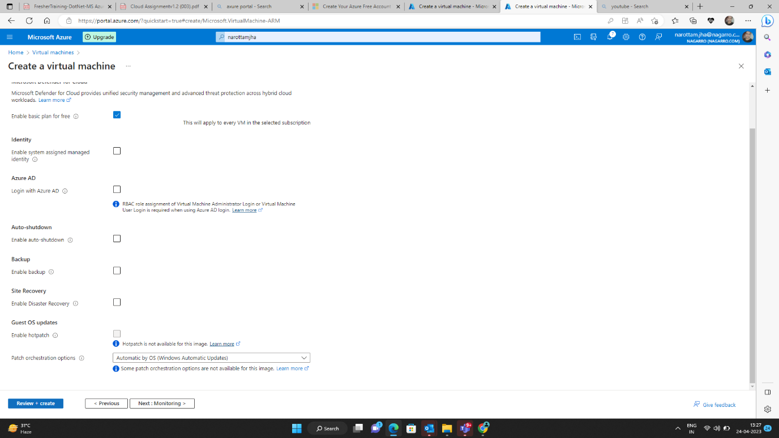

Step 6

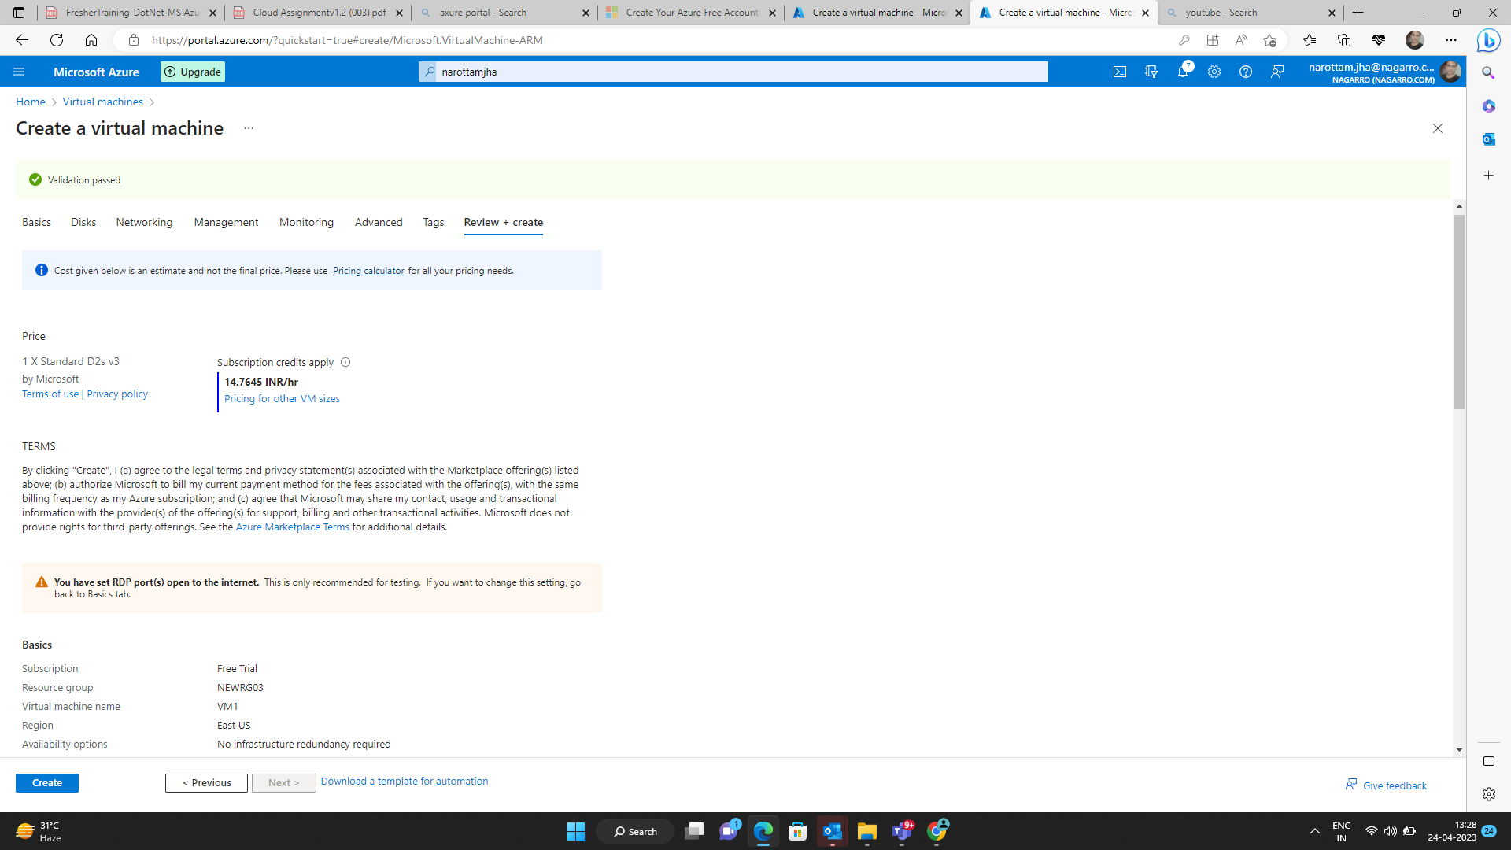

Now click on create

Virtual machine vm1 is created

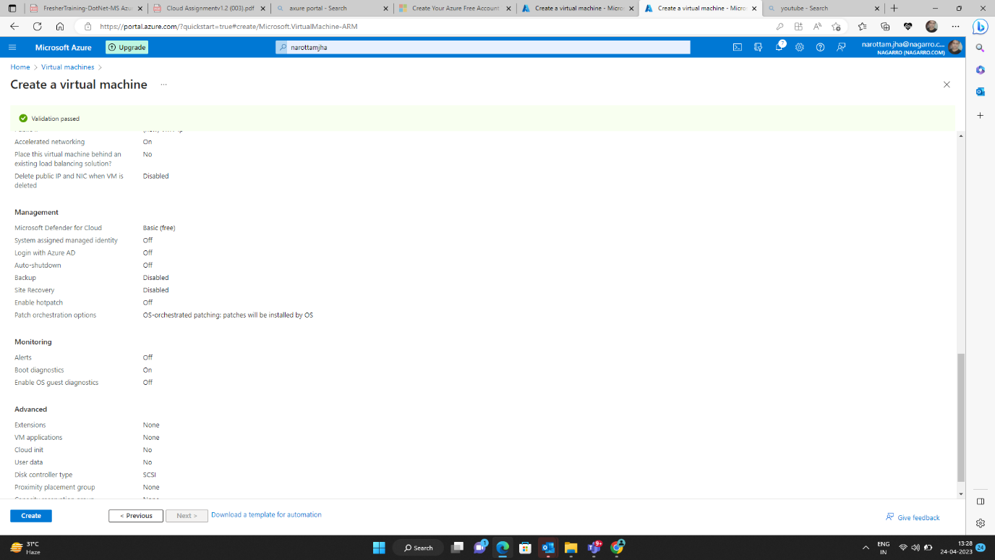

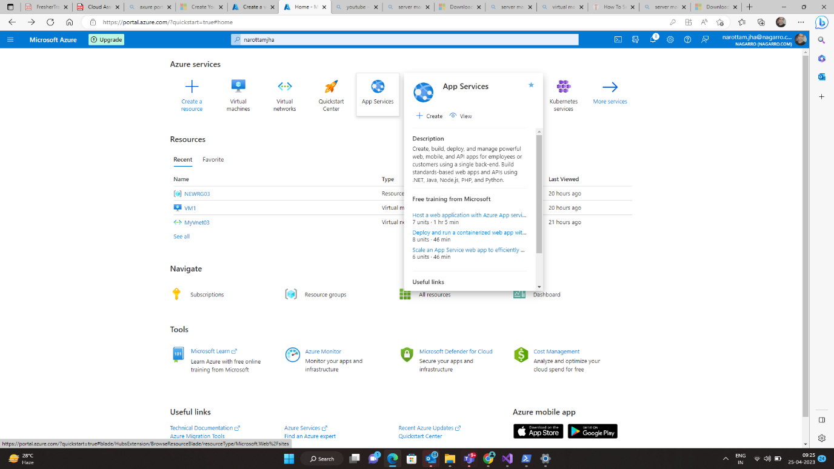

**Q3) Deploy the same application to Azure App Service. It should also leverage the database on the cloud.**

**Step 1**

**Go to App service**

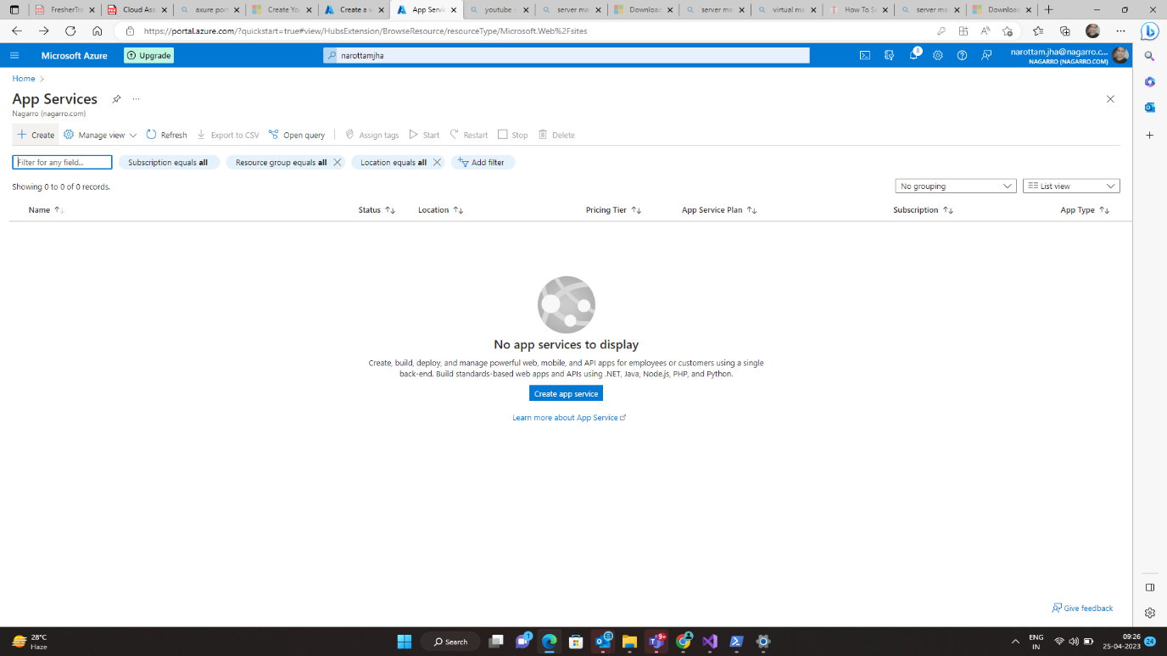

**Step 2**

**Create App service**

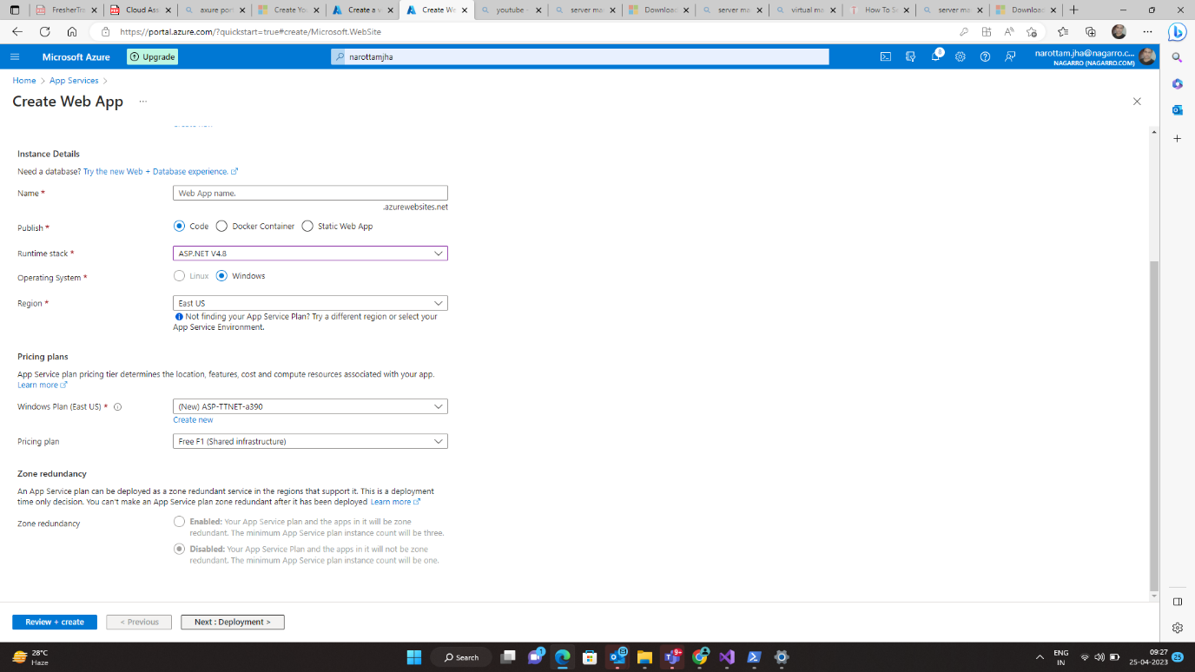

**Filling the data**

**Name – Web App service**

**RunTime Stack – ASP.Net v4.8**

**Step 3**

**Go to Deployment page click on Review + create**

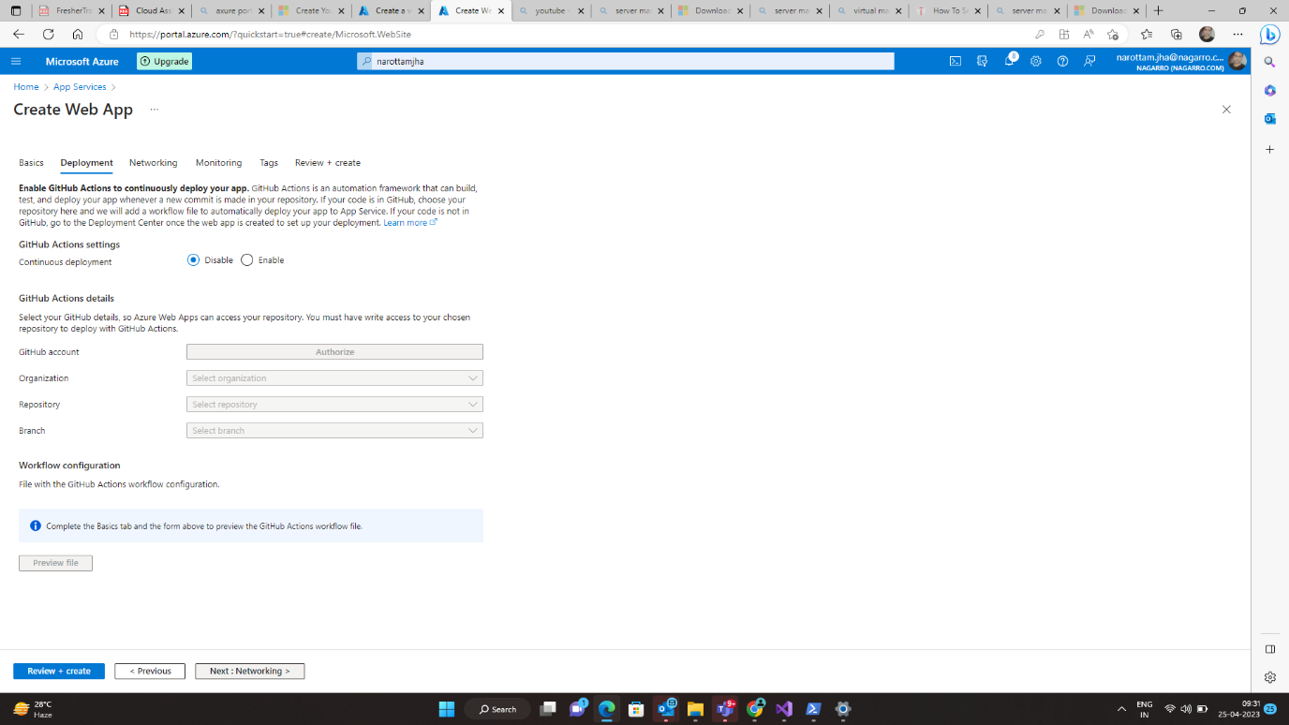

**Step 4**

**Go to Networking Page**

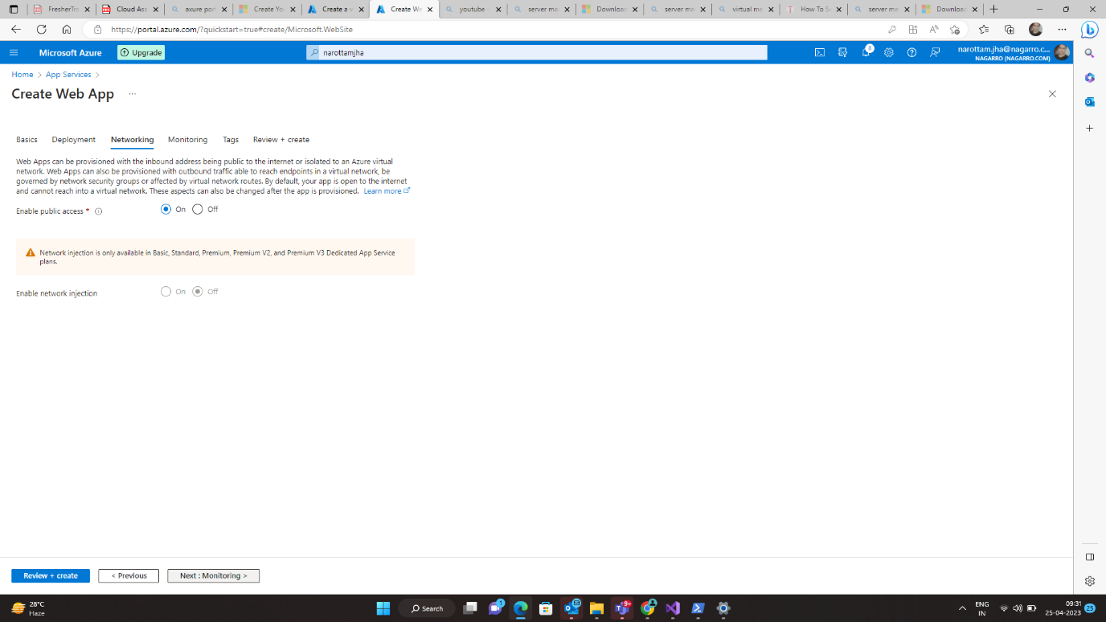

**Step 5**

**Go to monitoring page**

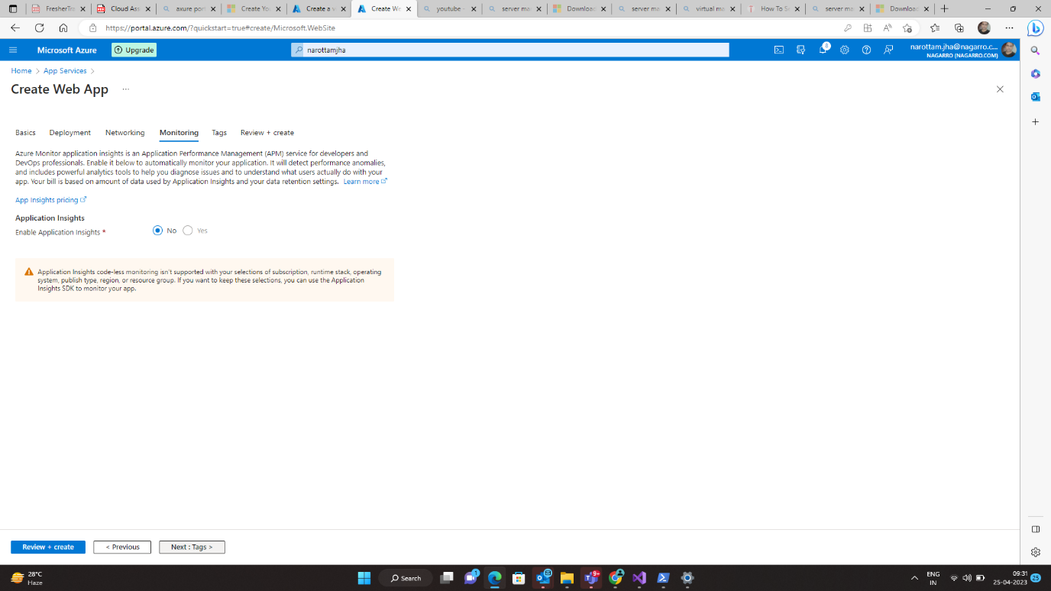

**Step 6**

**Go to tags page**

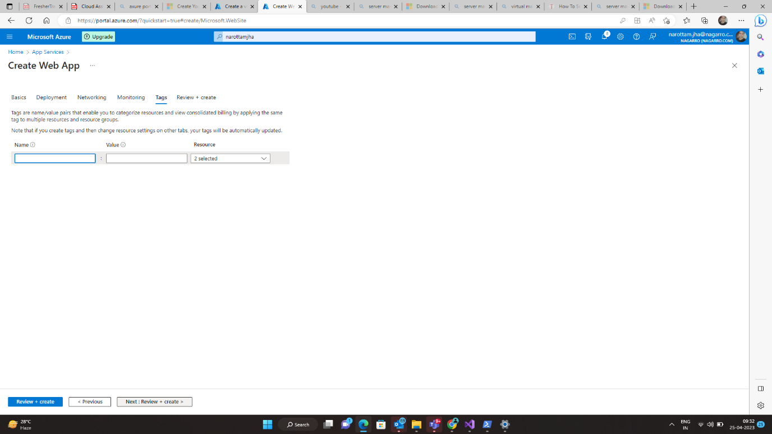

**Step 6**

**Go to Review + create** 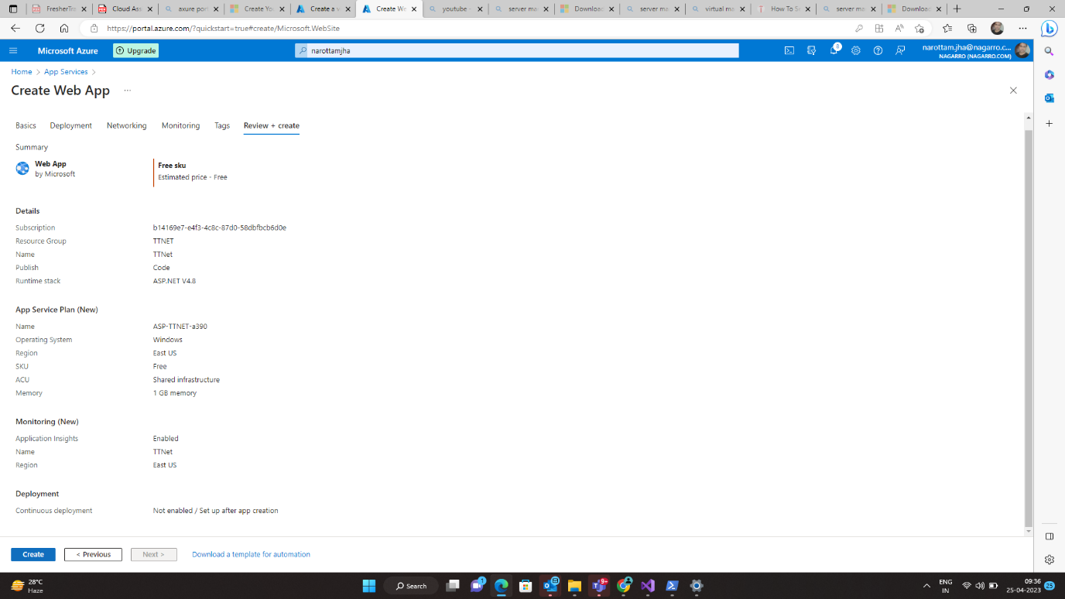

**Deployment in progress**

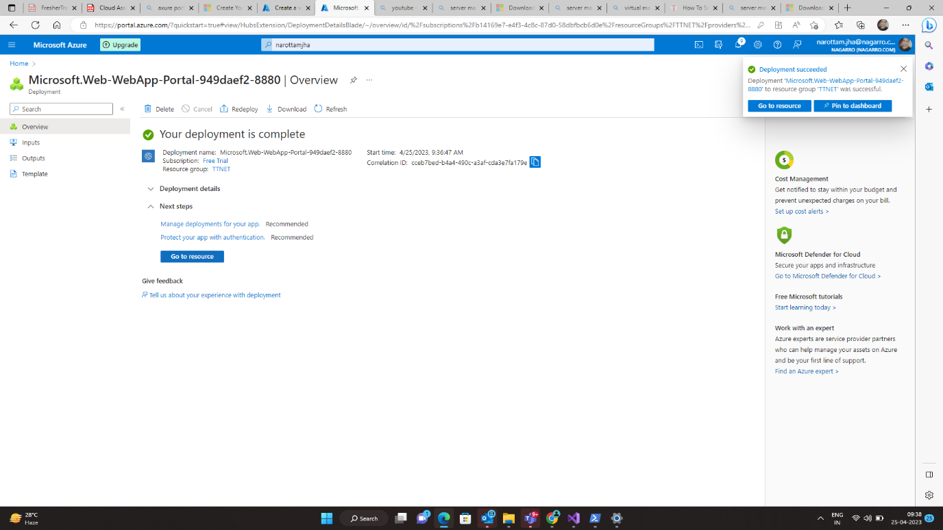

**Deploy the code on microsoft Azure .net web**

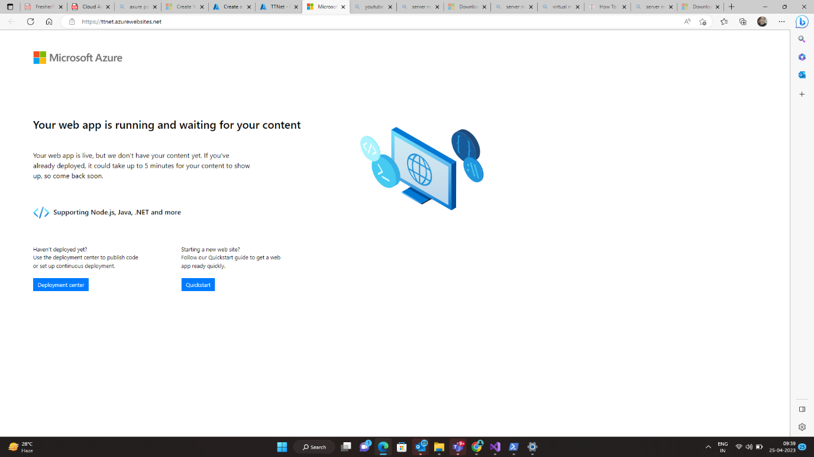

**Step 7**

**Home – Advance Tools**

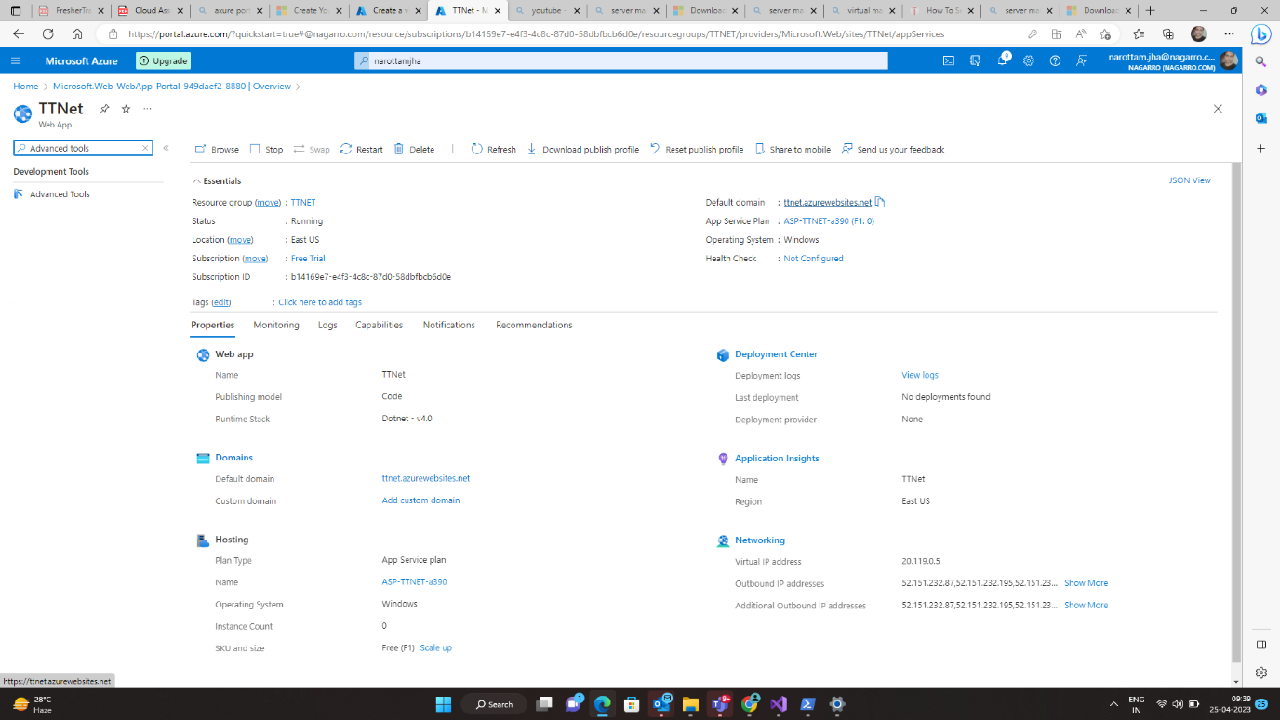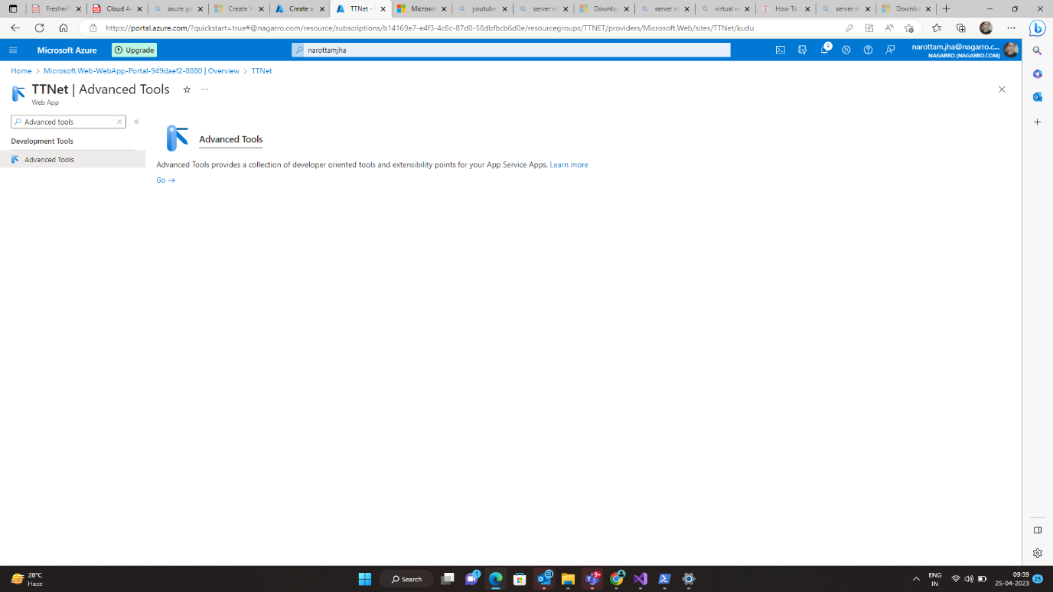

**Click on go**

**Step 8**

**Open cmd**

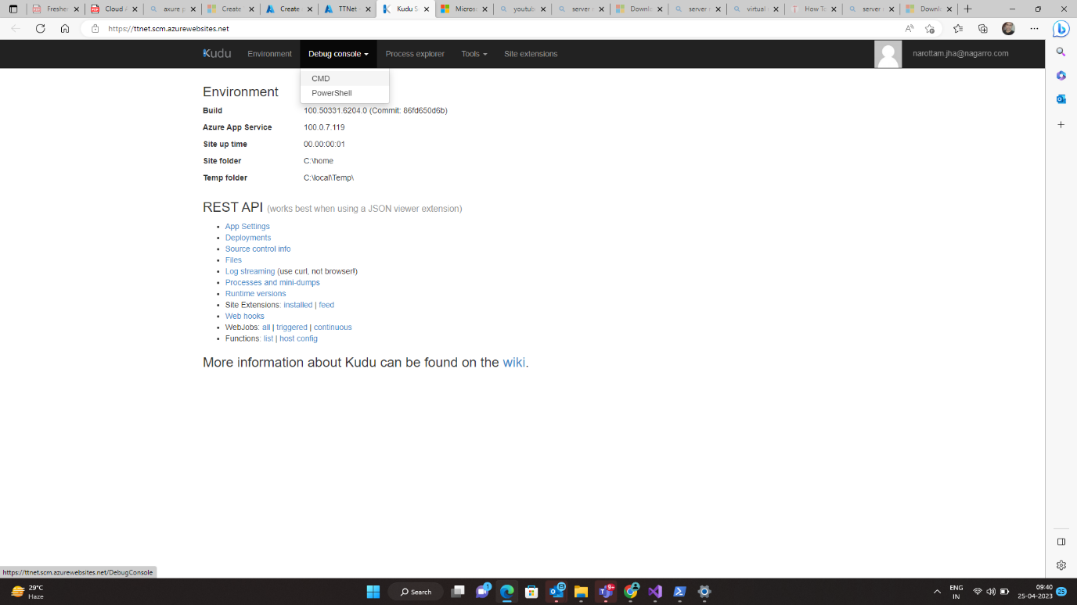

**Upload the code**

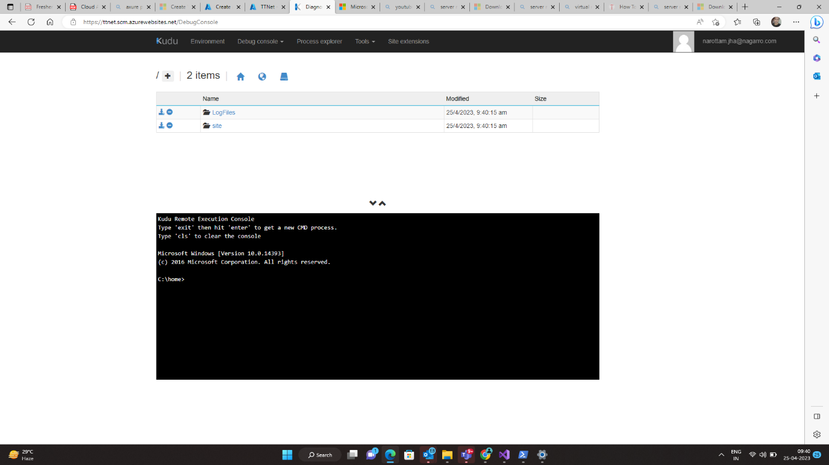

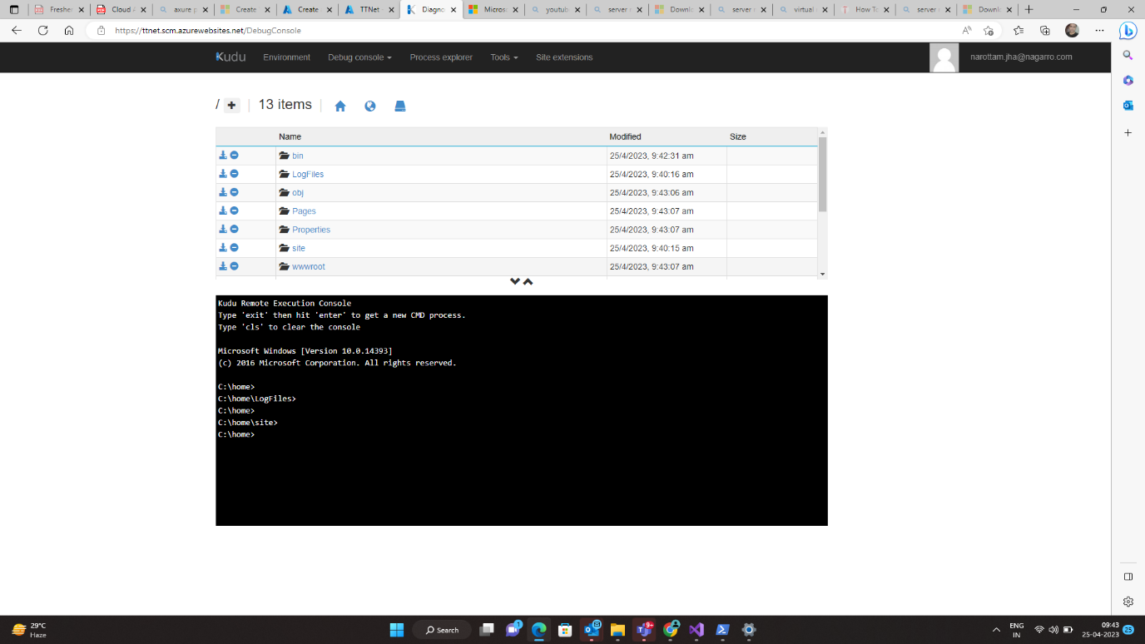

**Now run on that web**

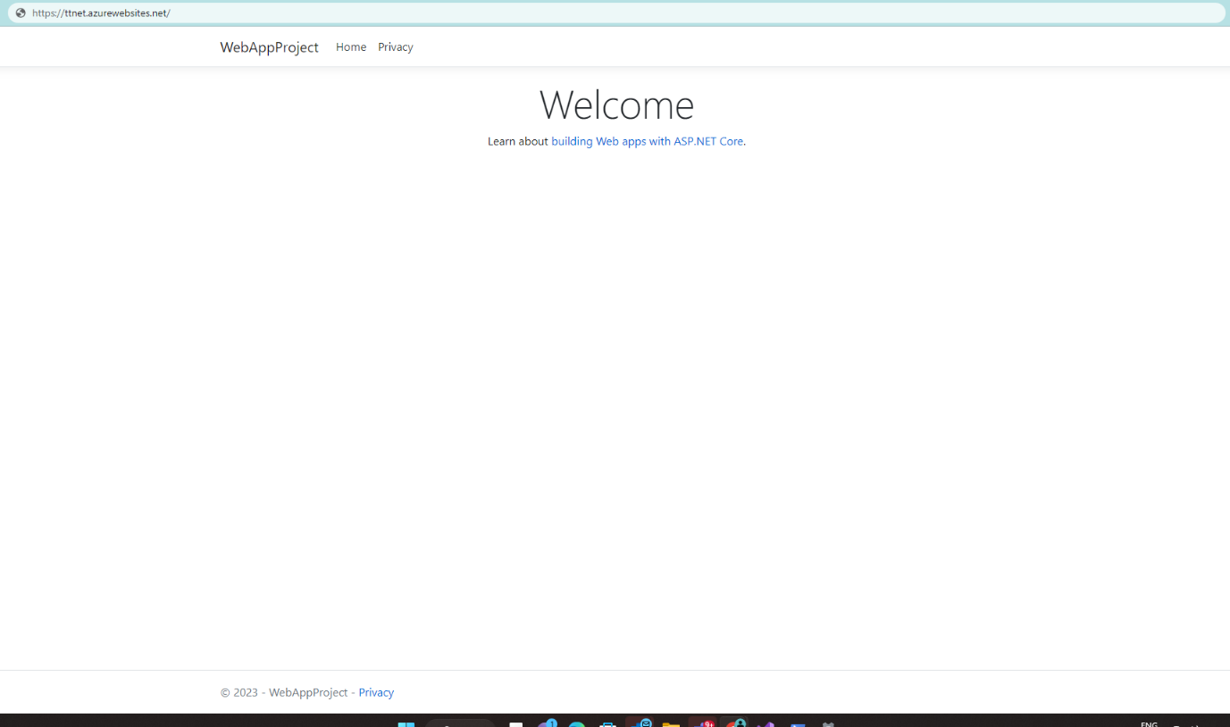

**Q3) Create the AKS cluster (2 nodes, smallest size VM) and deploy any two services on it. Services should be accessible from the internet**

Step 1

Click on kubernette service



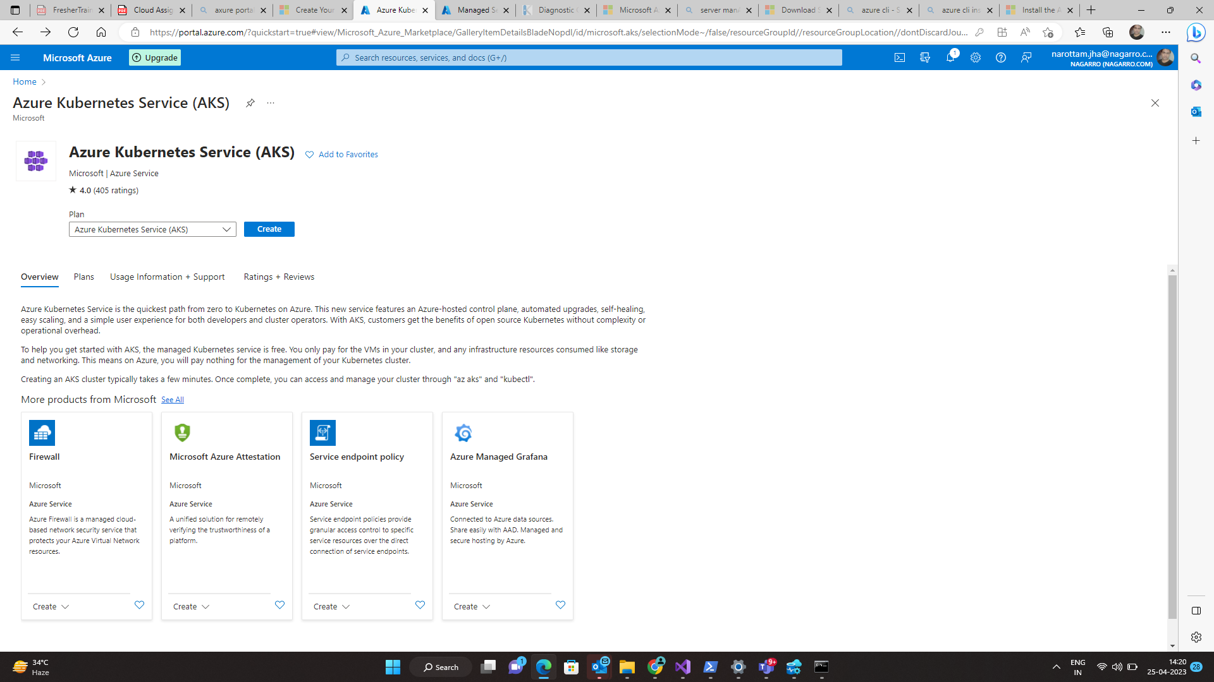

Step 2

Create kubernette cluster

Note – Allow of more than one node count range vwas not for free trial

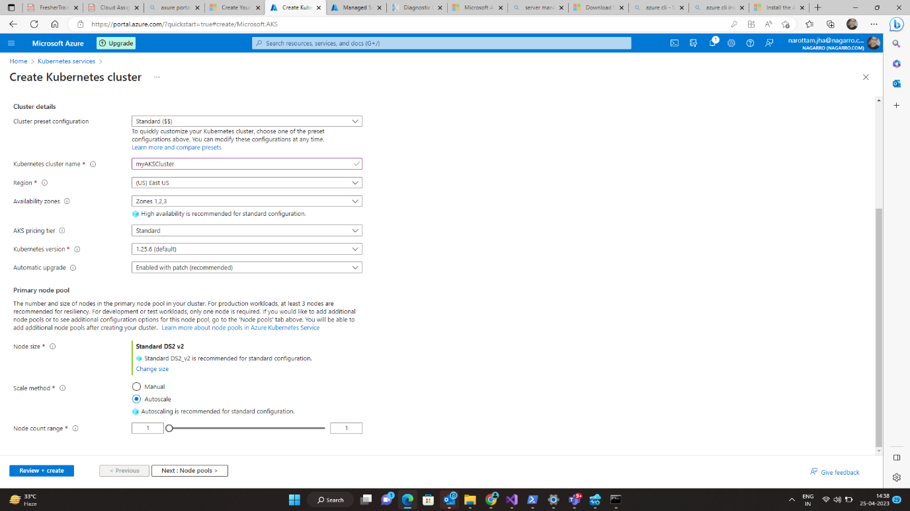

Step 3

Click – Review + create

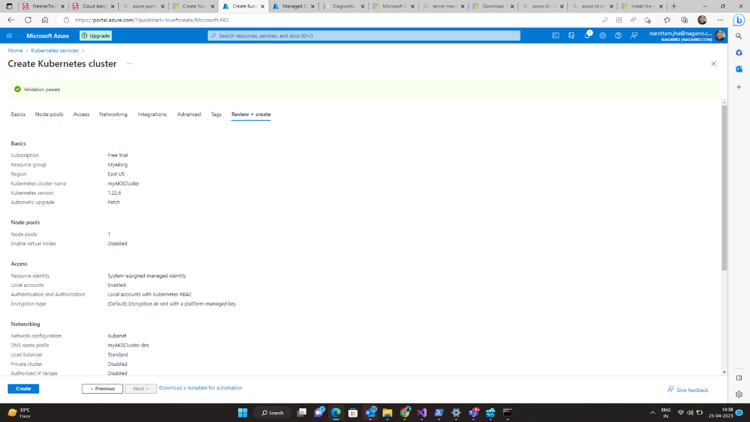

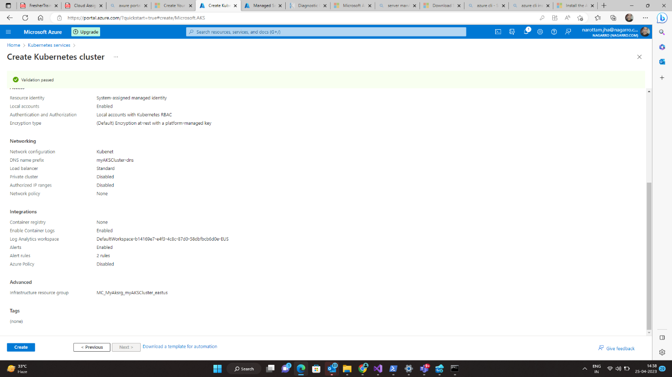

Step 4

Click – create

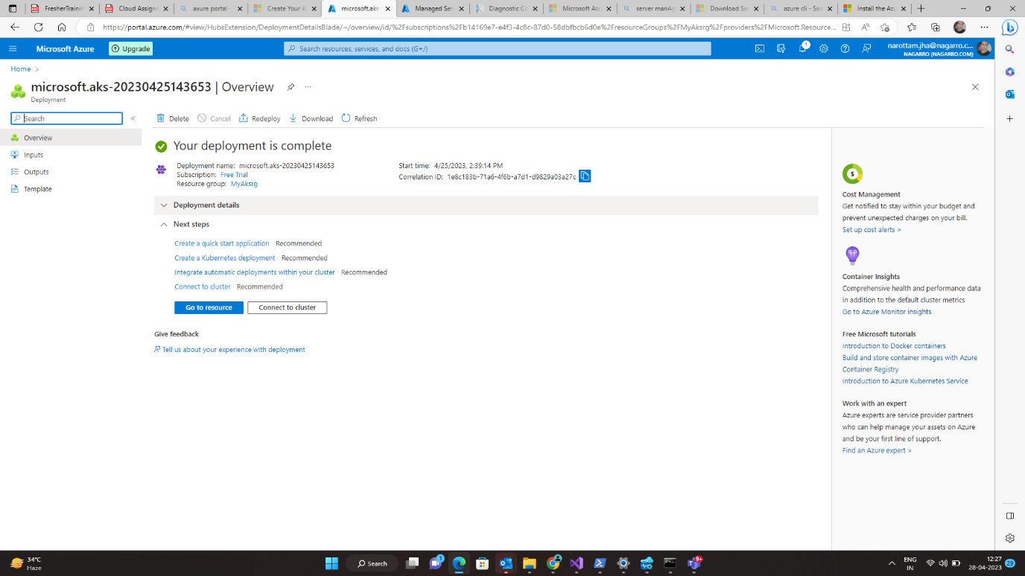

Deployment in progress

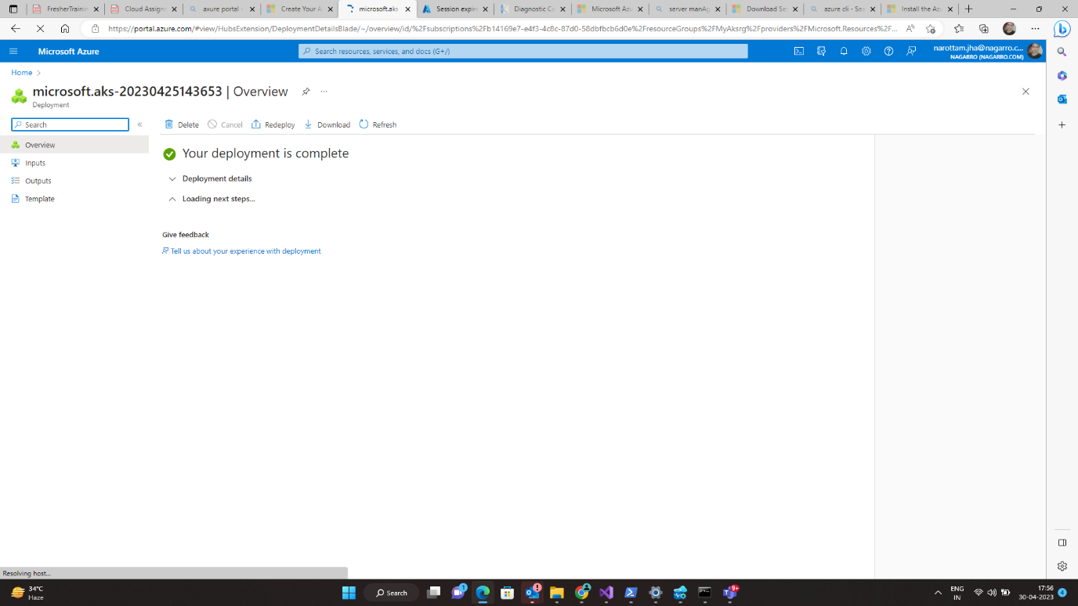

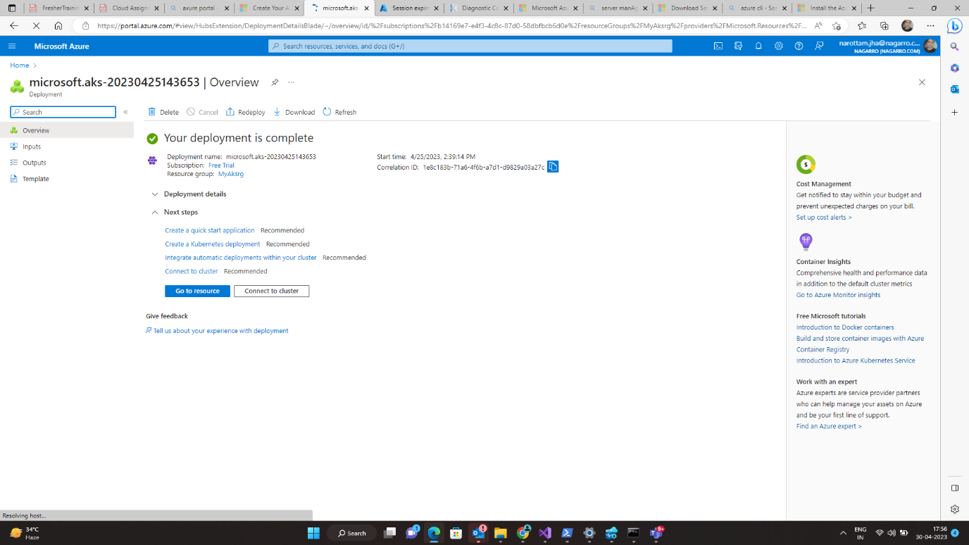

Step 5

Click – Go To Home

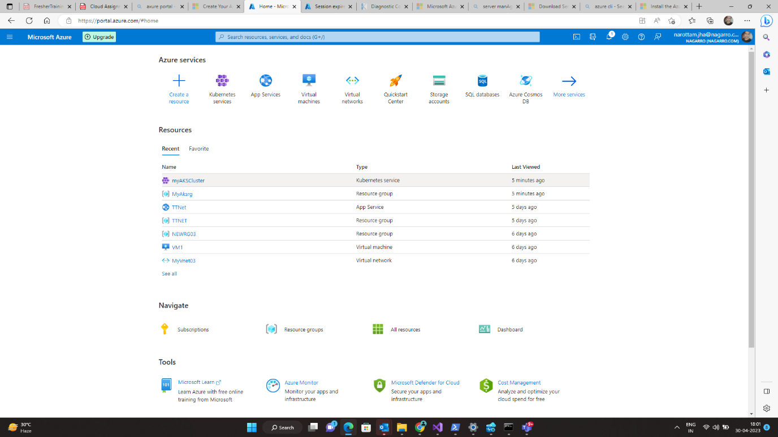

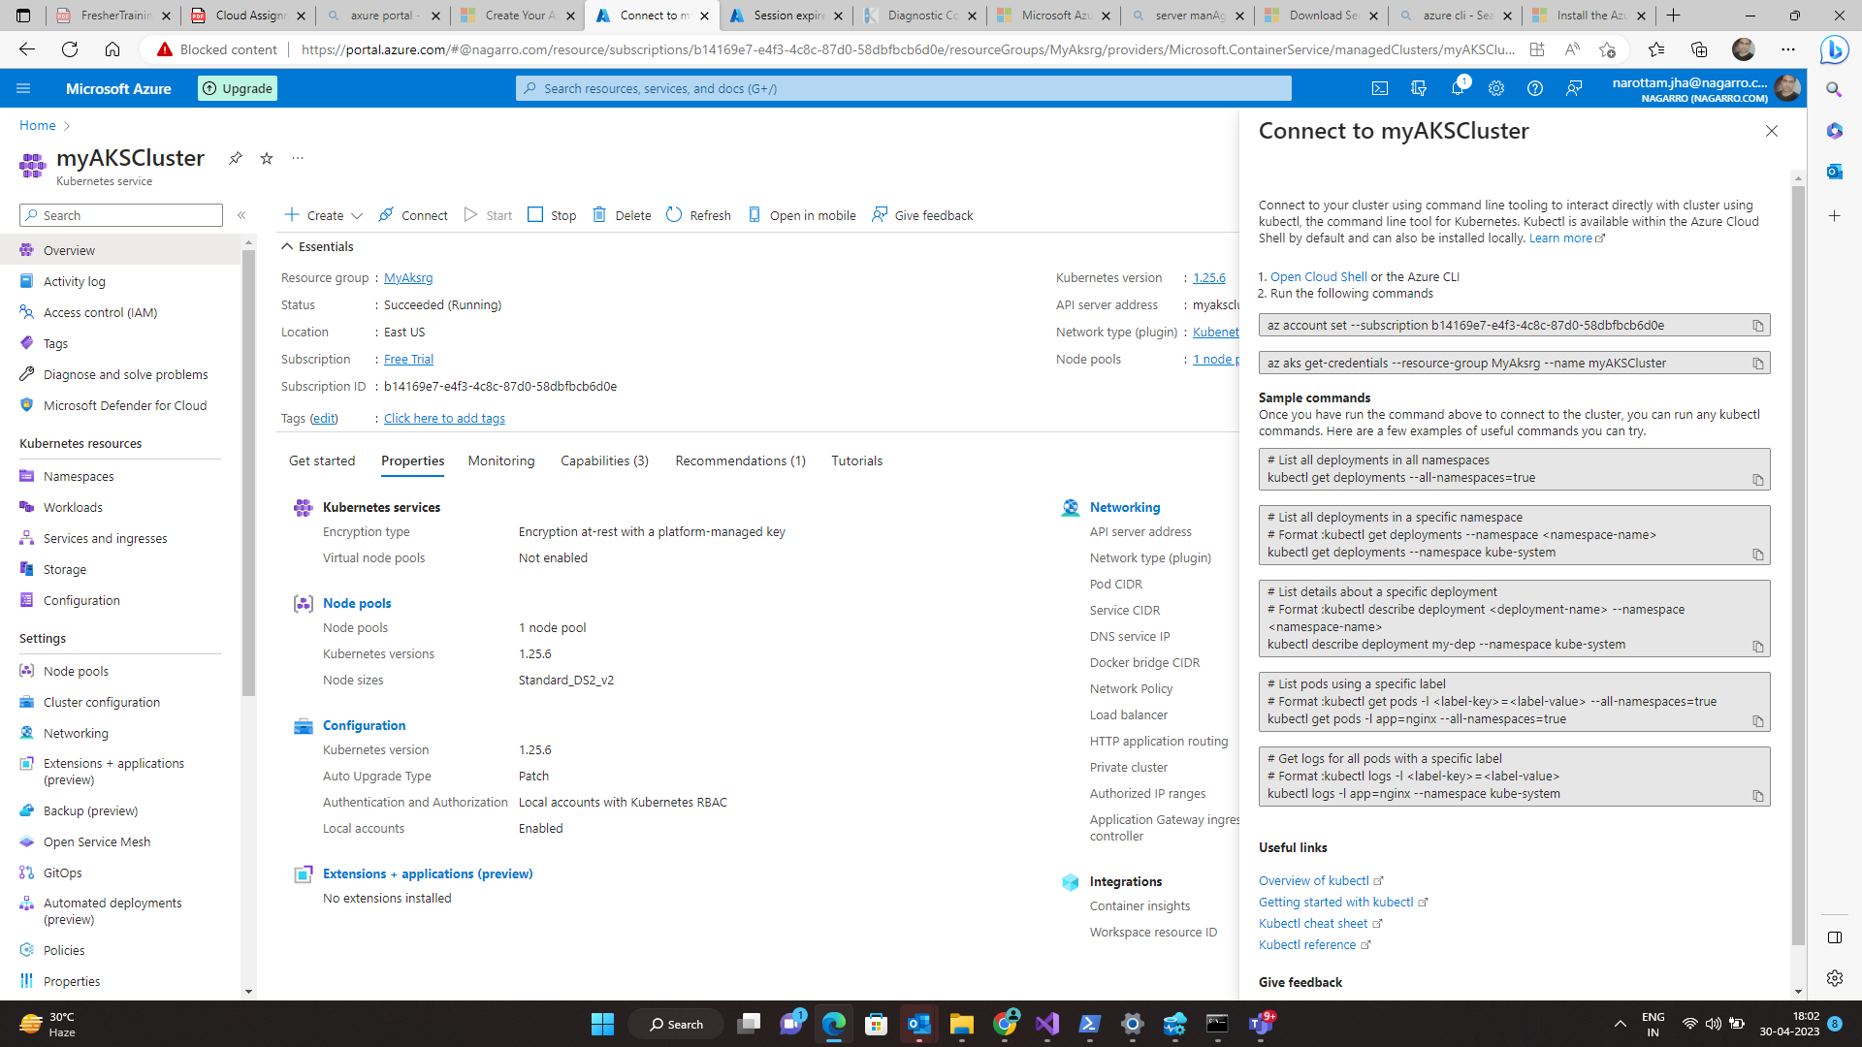

**Step 6**

**Go to nodepool**

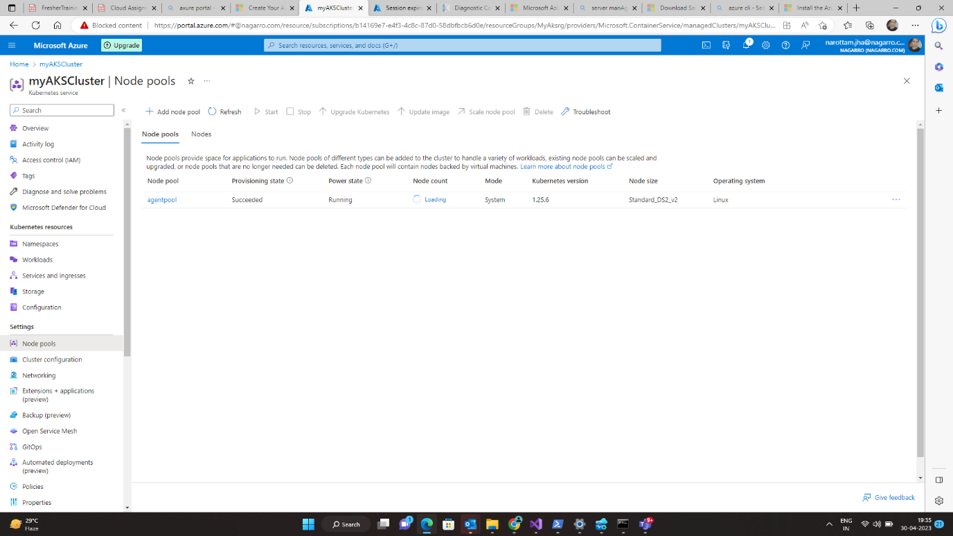

**Note –Running command on bash was not in free trial**

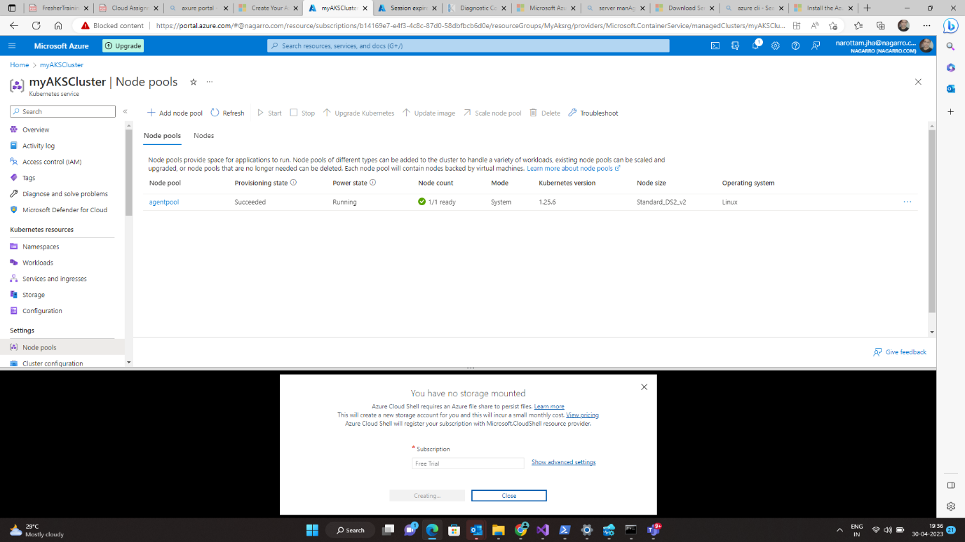

**Q5)** Create an Azure function that should trigger as soon as you upload a file in the blob storage. Function should be able to print the name of the file uploaded in the function.

Step 1

**Go to Storage Account**

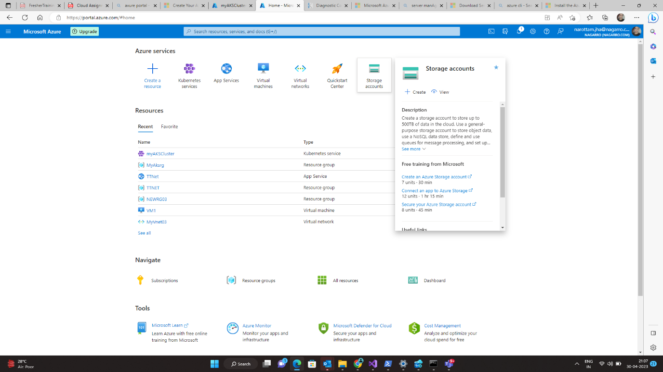

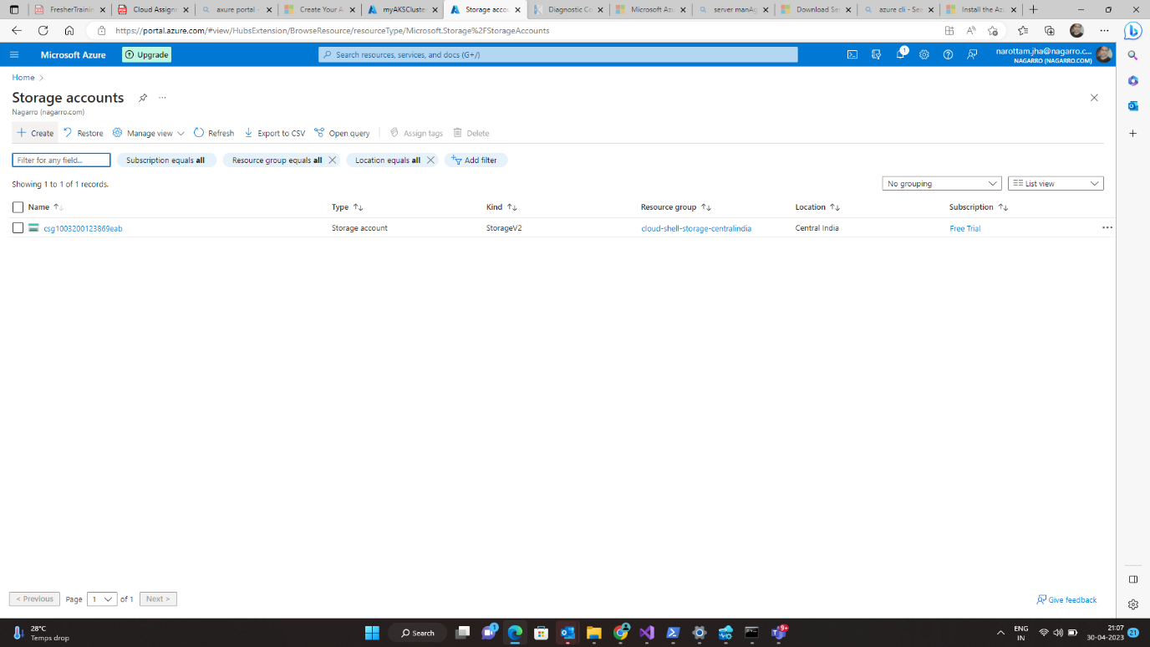

**Step 2**

**Create And Fill the Data**

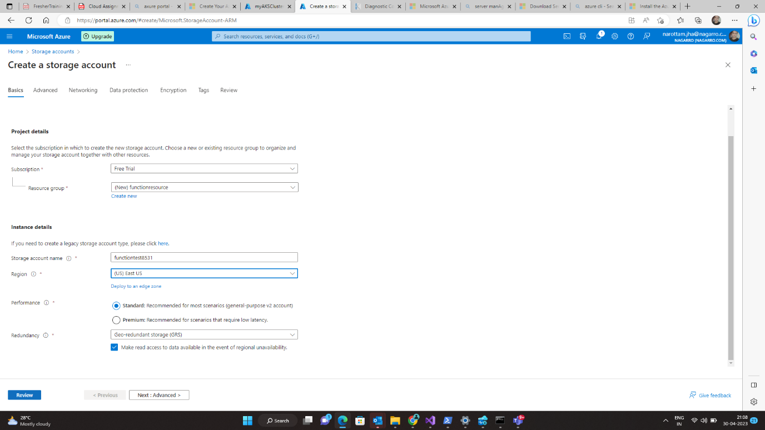

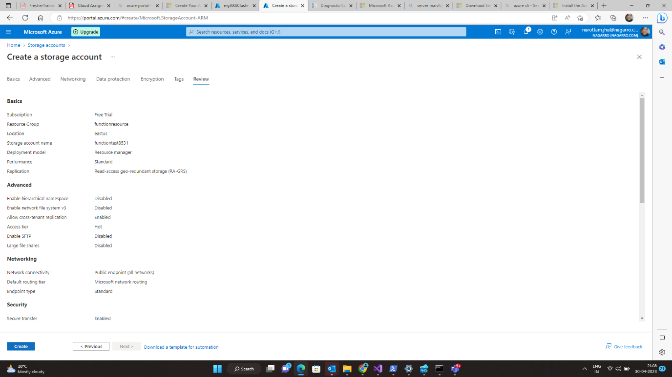

**Step 3**

**Click on create**

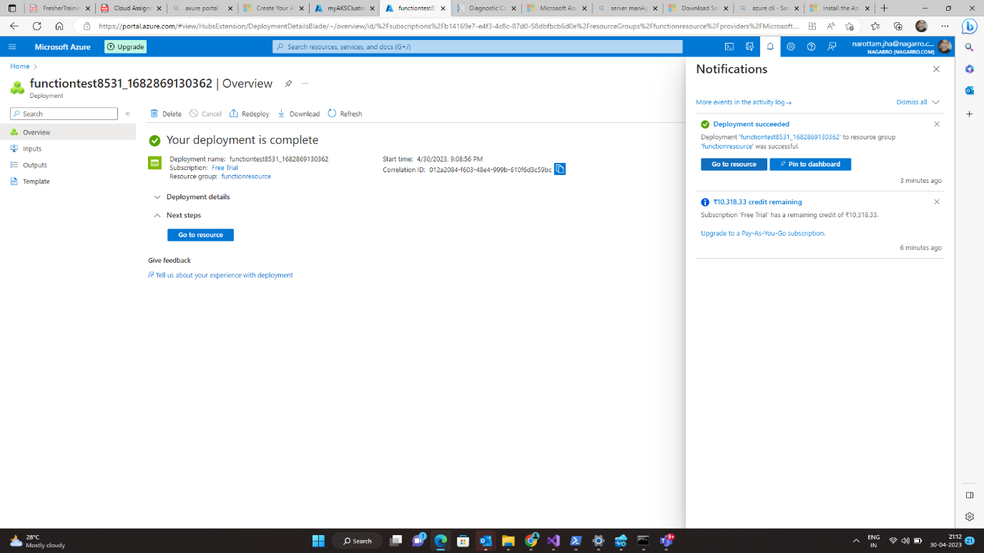

**Step 3**

**Go to Resource**

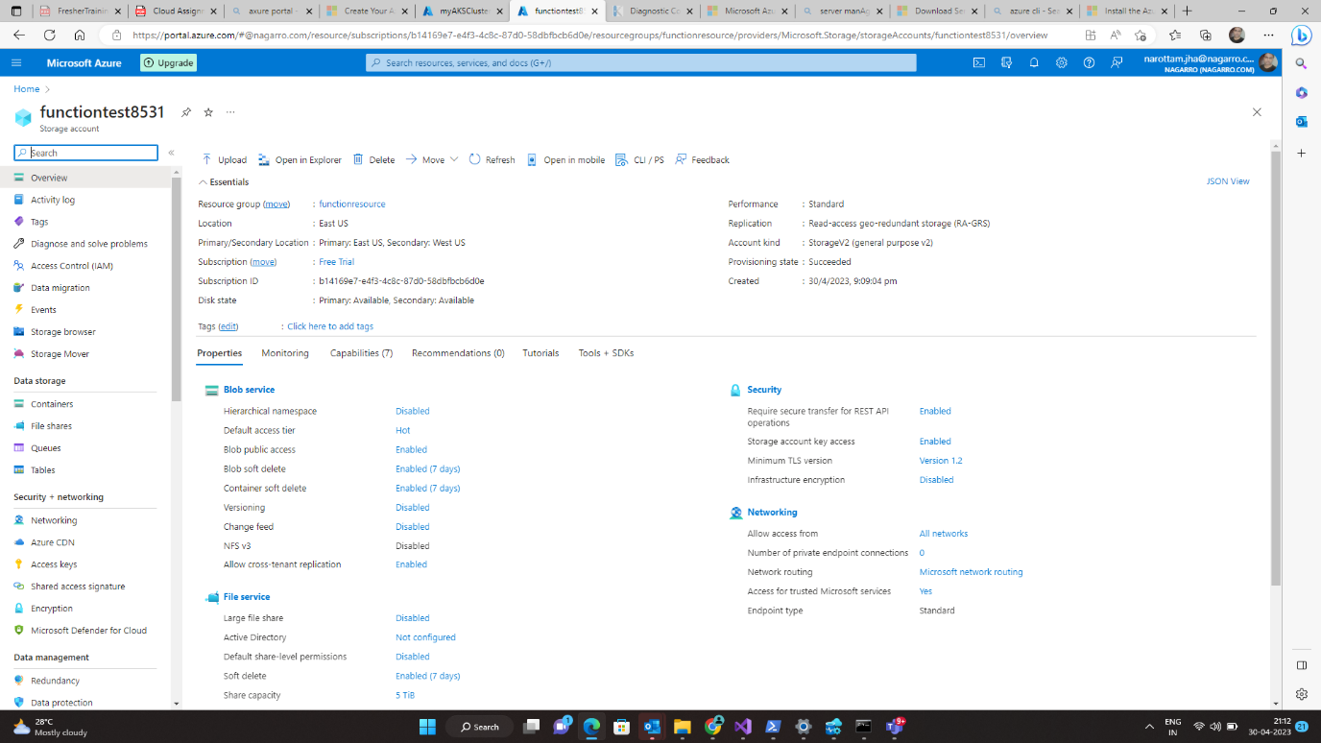

**Step 4**

**Click on Home and Go to Function App**

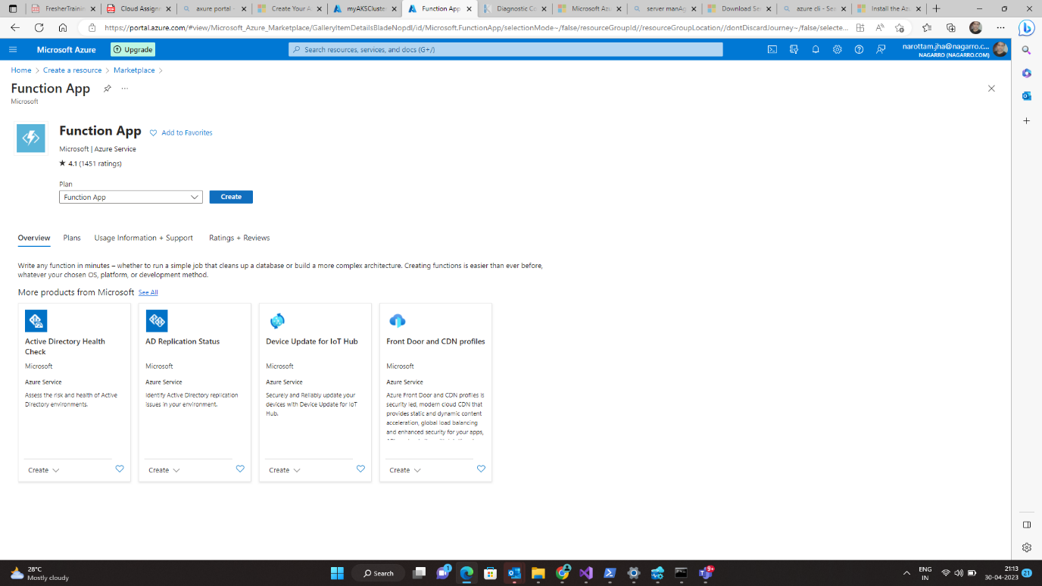

**Step 5**

**Fill the Data and click on Review + create**

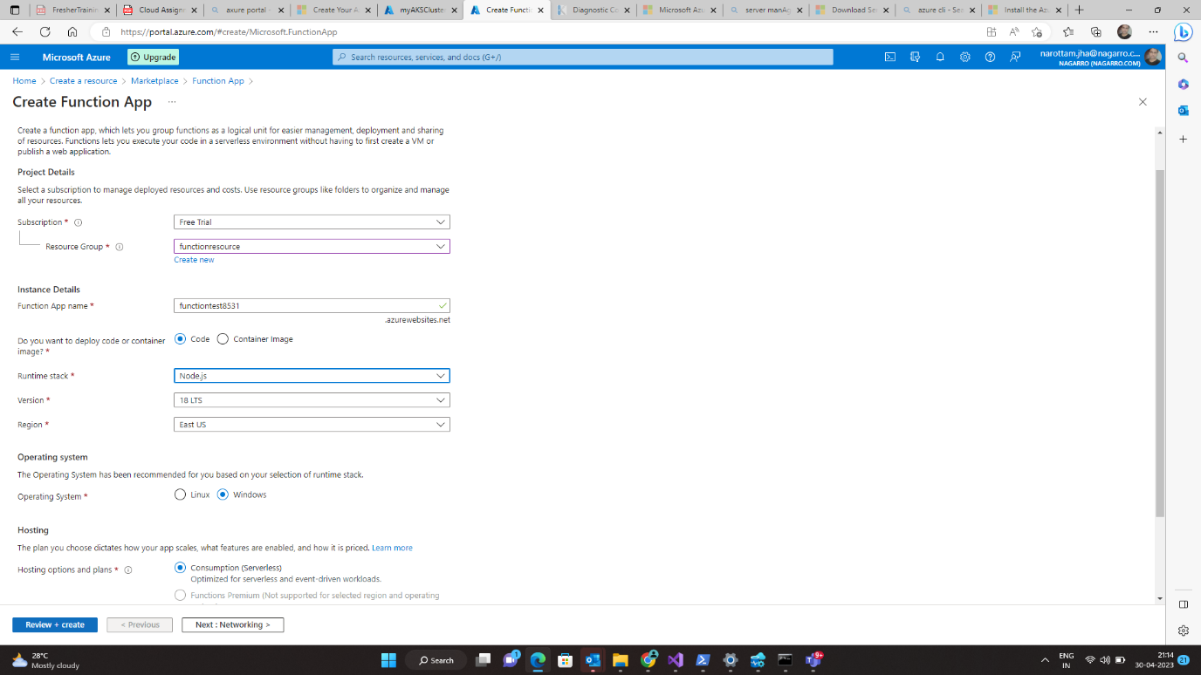

**Step 6**

**Click on create**

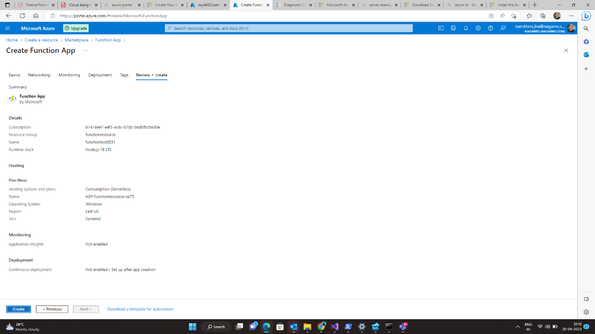

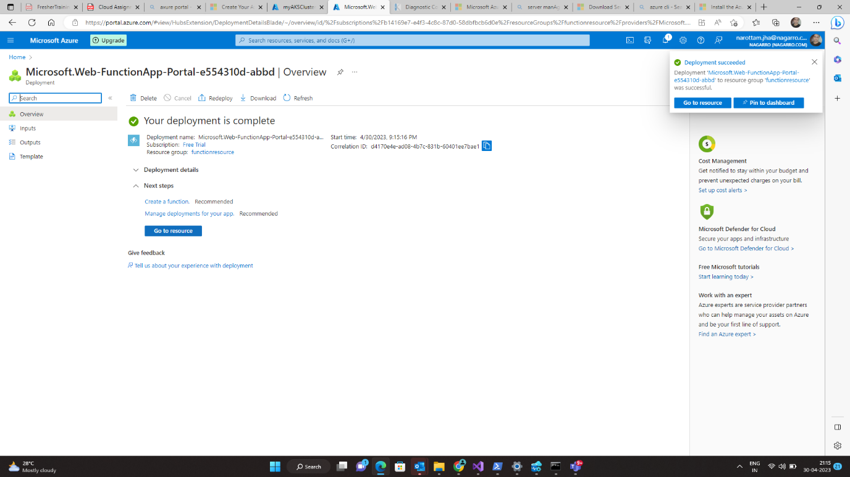

**Step 7**

**Go To Resource – Function – Create**

**Select a template – Azure bob storage trigger**

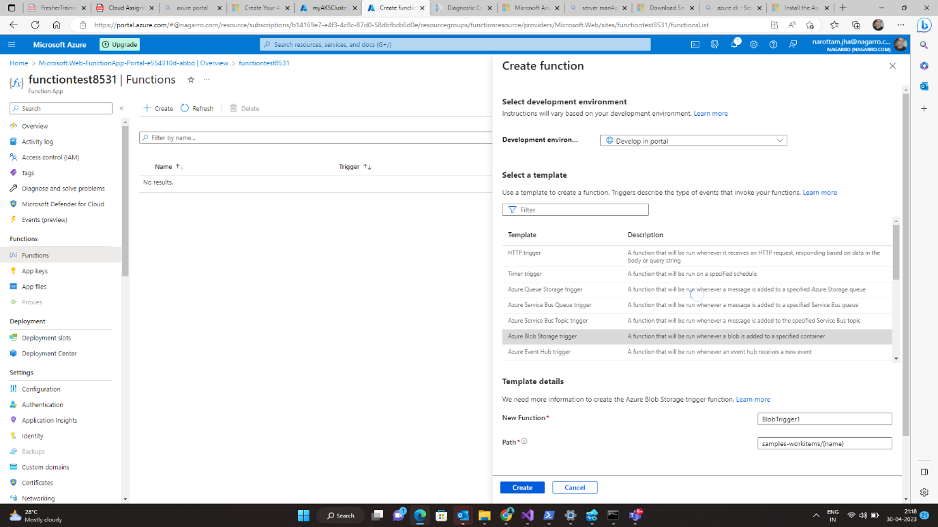

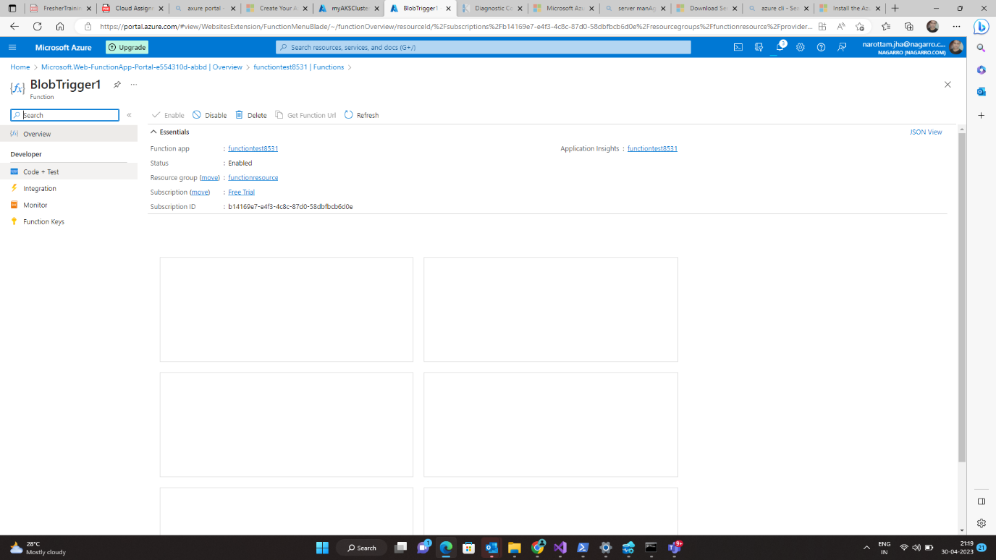

**Step 8**

**Click – code + Test –**

**Then click – Test and Run and copy the Body**

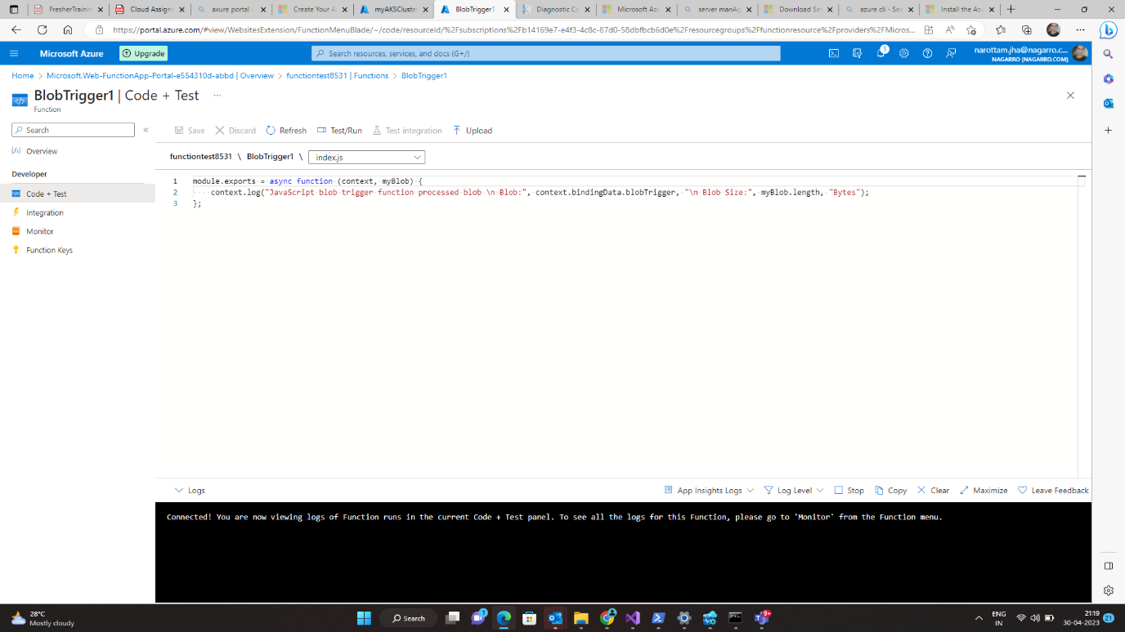

**Go to Home**

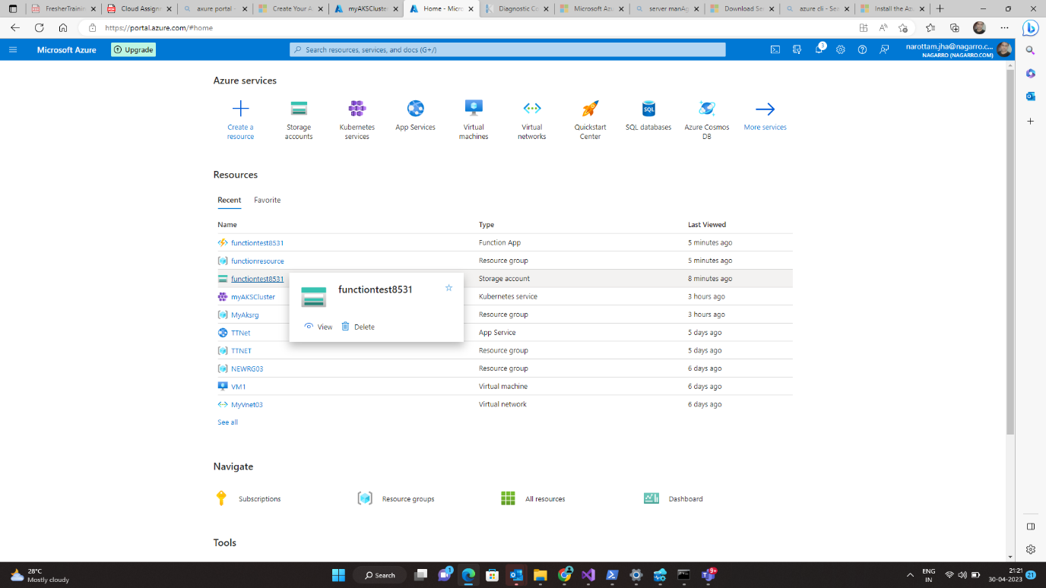



**Step 8**

**Click on new container and upload the file**

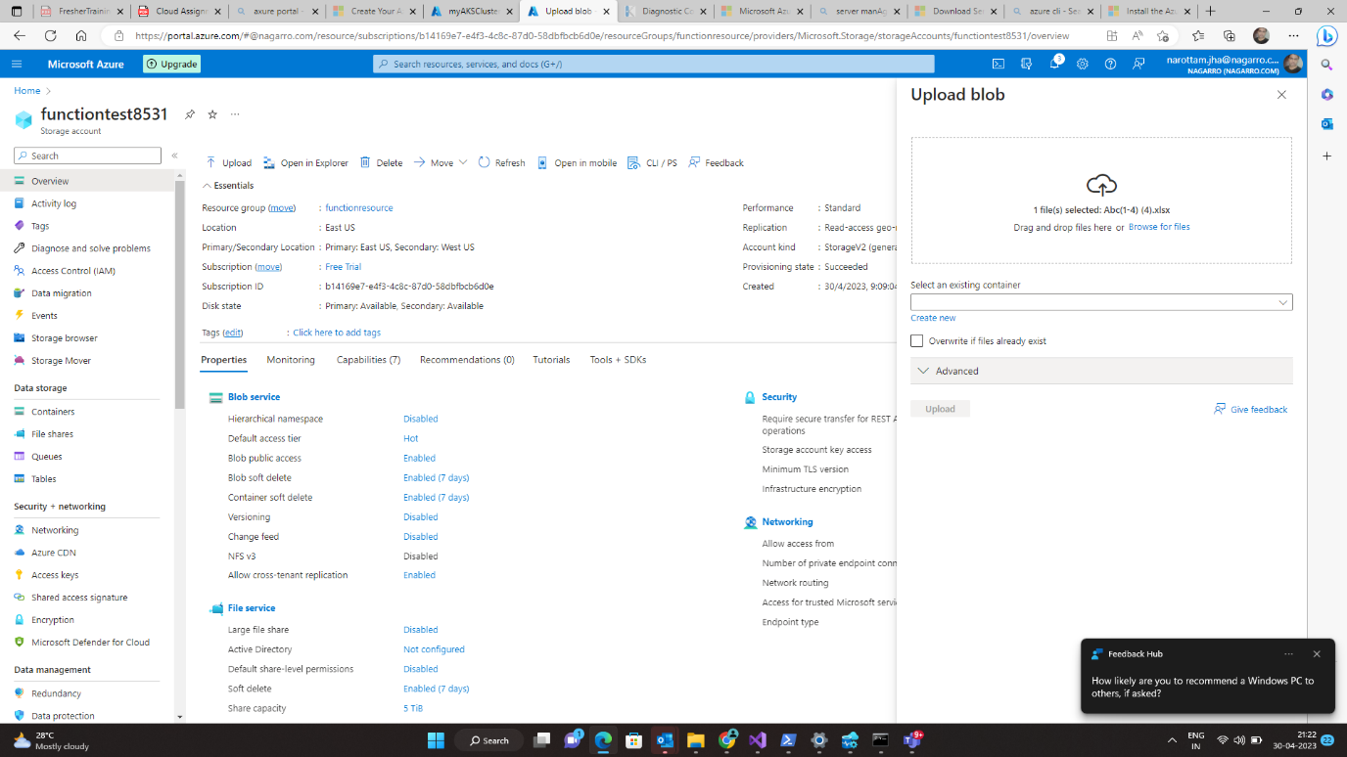

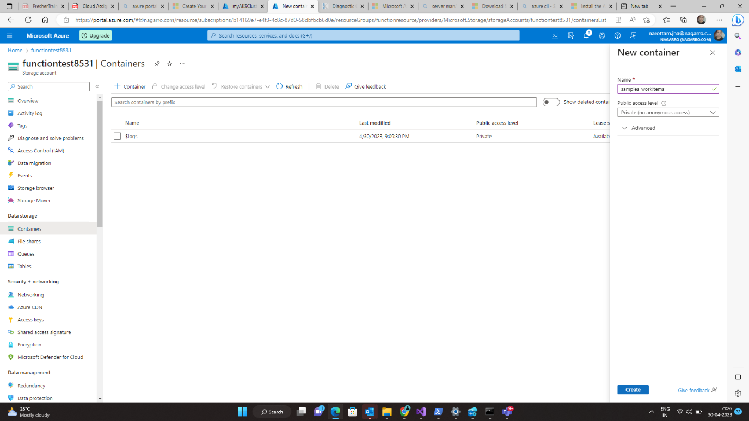

**Successfully Uploaded**

